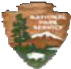
National Park Service
U.S. Department of the Interior
Junior Ranger

Ninety Six National Historic Site

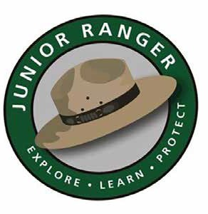

Junior Ranger Activity Booklet

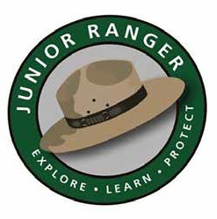

Welcome To Ninety Six National Historic Site

Explore, Learn, Protect, Be a Junior Ranger!

What is a Junior Ranger?
Junior Rangers are important people, just like you, who help protect Ninety Six National Historic Site and other National Parks around the United States. Junior Rangers learn a lot about the history and the environment at the National Parks they visit. You can be a Junior Ranger at home too, by telling your friends how you became a Junior Ranger.
You can learn more about National Park areas by visiting www.nps.gov.

Or, check out our online Junior Ranger program by visiting www.nps.gov/webrangers.

How to become a Junior Ranger...
Complete the activities that are in the booklet for your age group to earn your Junior Ranger Badge. Complete 2 extra activities to earn the Junior Ranger Patch.
Ages 6 and under – please complete 3 out of 12 activities in the booklet to become a Junior Ranger.
Ages 7 to 9 – please complete 5 out of 12 activities in the booklet to become a Junior Ranger. Two of these activities must be Challenging.
Ages 10 to 12 – please complete 7 out of 12 activities in the booklet to become a Junior Ranger. Four of these activities must be Challenging.
Ages 13 and up – please complete 9 out of 12 activities in the booklet to become a Junior Ranger. Six of these activities must be Challenging.

*Activities are marked by difficulty levels*

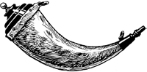
Powderhorn
= Easy
Cartridge Box
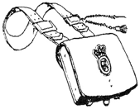
= Challenging

After completing your activities, bring your booklet to a Park Ranger at the front desk of the Visitor Center to have your certificate signed and to receive your badge.

Have Fun & Good Luck!

This book belongs to:

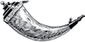
Difficulty Level:
Park Signs and Symbols

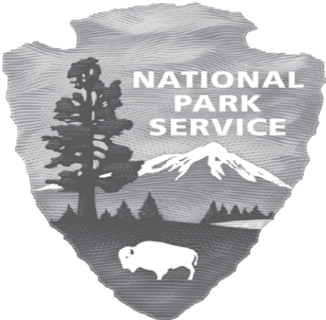One way of knowing that you are in a national park is to look for the emblem of the National Park Service – the arrowhead. You can find it throughout every National Park Service site on brochures, signs, and various other park related items.

The arrowhead and the pictures inside of it represent the most important parts of the national park system. The Sequoia tree and bison represent plants and animals; the mountains and water represent scenic and recreational places; and the arrowhead represents historical and archaeological resources.

Think about national parks that you have visited. If you could create a new emblem for the National Park Service, what would it look like? Draw it in the space to the right.

What do the different parts of your emblem stand for?

Visitor Center

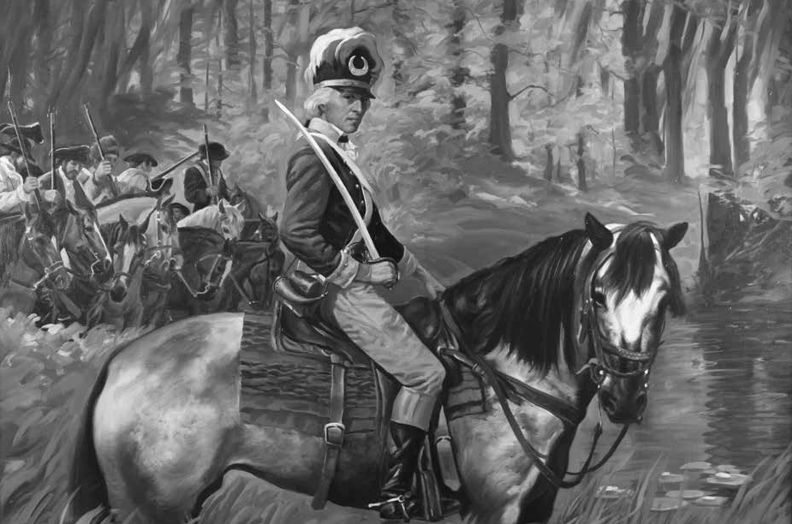

Activities

“Ninety Six A Frontier Crossroads”

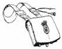
Difficulty Level: Enjoy the Show!

Watch the video in the Visitor Center and learn about the historic events that took place at Ninety Six National Historic Site. A ranger is on duty to help you with any questions you might have.

- Why is it called Ninety Six?

- What Native American tribe lived near what is now Ninety Six?

- Who was Robert Gouedy?

- How many days did the siege last?

- Were Nathanael Greene and his troops successful with their siege? Why or why not?

Write down one fun fact of your own that you learned in the video:

Difficulty Level:
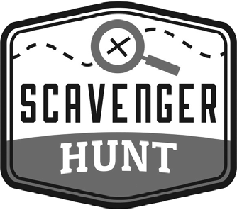

Ninety Six National Historic Site is an area of much history, whether it’s about the settlement of European colonists in the mid-1700’s or as a prominent area for the Southern Campaign during the American Revolution.
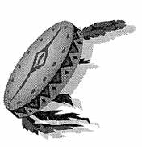
Go to the Museum exhibit to answer the questions below:
For over 12,000 years, Native Americans were the first to live in the area that today is called Ninety Six. The Cherokees hunted game such as deer, elk, buffalo and turkey here into the 1700’s.
- Find the mannequin of the Cherokee Indian. How many feathers is he wearing?
- The Cherokee Path was a major trade route between Charleston and the Cherokee country. In 1753, a man named Robert Gouedy established a trading post at Ninety Six.
Look at the trade items from Robert Gouedy’s inventory. List 5 items.

Scavenger Hunt continues onto next page.

- Find the African-American mannequins in the museum.
African-Americans played an important role in the settlement and development of Ninety Six and the 18th century backcountry of South Carolina.
Why did they play such an important role?

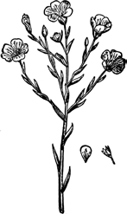
- Flax is a cultivated plant that has pale blue flowers and seeds that have linseed oil. Textile fiber comes from the slender stems of the flax plant. The flax fiber is a light-colored textile fiber.

Look at the Settlers and Agriculture exhibit. What are the four steps to preparing flax?

What did the settlers do with the flax?

- Find the armband and bracelets worn by the Cherokees. Why did they wear these bands?

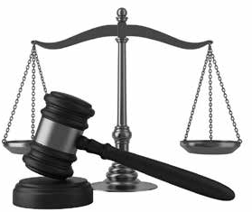
- In the Law and Order exhibit, the settlers of the backcountry wanted two things that only Charleston had in South Carolina in 1769.

List the two things they wanted.

- The American Revolution was a civil war where neighbors were fighting neighbors and families were fighting families.

What was the Rebel position during the American Revolution?

What does it mean to be a Loyalist?

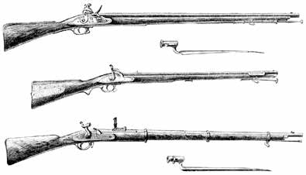
- What kind of musket is hanging from the museum wall?

- Look at the Siege of Ninety Six exhibit.

When was the Siege of Ninety Six?

How long did it last?

- Think Like An Archaeologist!
Select an object from your pocket or a family member’s pocket to analyze as if you were an archaeologist from 500 years in the future. In the space below, describe what the object is made out of, what its uses might be, who used it, and what it tells us about our civilization.

Historic Trail

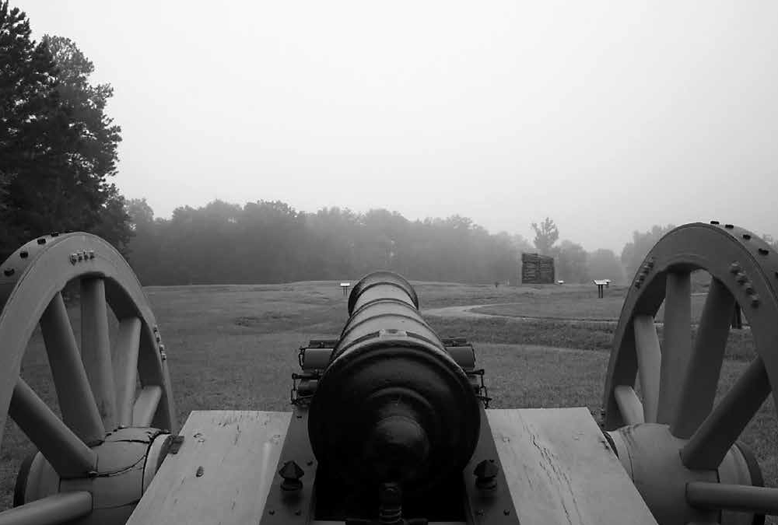

Activities

Difficulty Level:

Ninety Six’s Bingo!

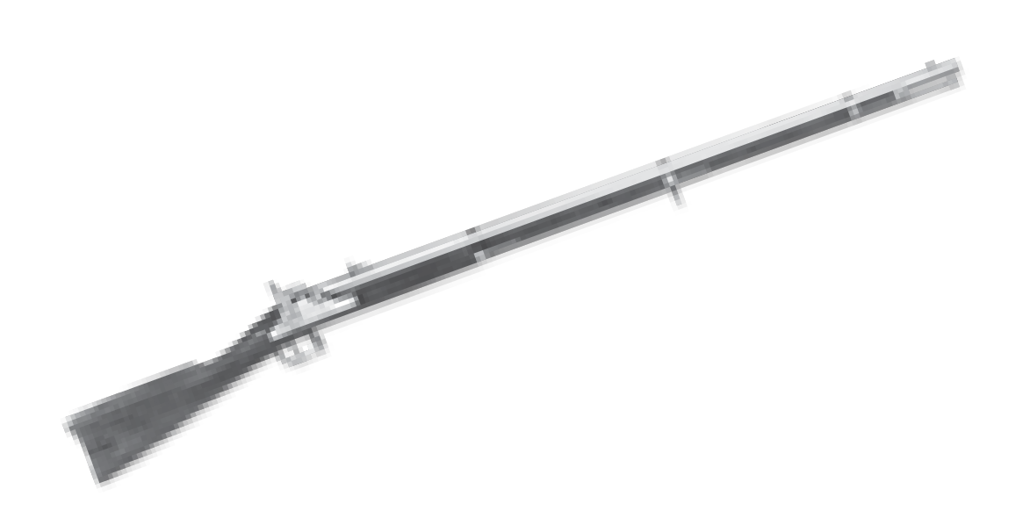
Watch for these plants and animals on your journey through Ninety Six National Historic Site. When you find one mark it with an “X”.
Try to find 5 in a row across, down or diagonally. Try to find all 4 corners, or try to find them all!
Good Luck!!!

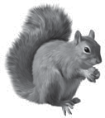  Squirrel | 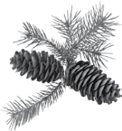  Pine Cone | 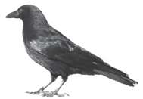  Crow | 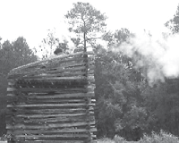  Rifle Tower |   Butterfly
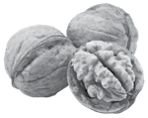  Walnuts | 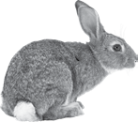  Rabbit | 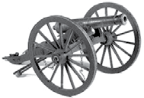  Cannon |   Bird’s Nest | 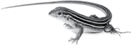  Lizard
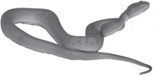  Snake | 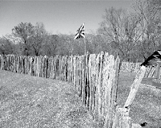  Stockade | FREE  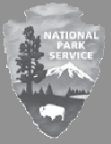  SPACE | 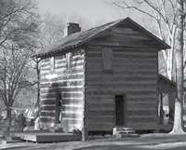  Cabin | 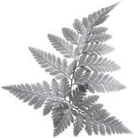  Fern
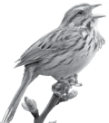  Bird Chirping | Musket | 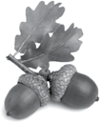  Acorns | 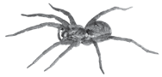  Spider | 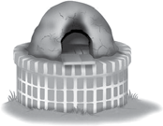  Beehive Oven
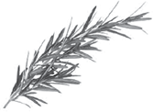  Rosemary | 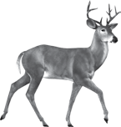  Deer | 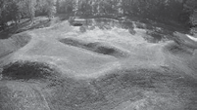  Star Fort | 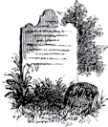  Birmingham Memorial | 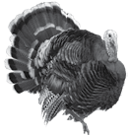  Wild Turkey

How would you feel if you were a Patriot soldier during the
Siege at Ninety Six?
Difficulty Level:

Find a spot in the siege area along the historic trail. Try to sit there and imagine what Ninety Six would look like during the American Revolution. Imagine seeing the Star Fort, 14 feet tall from the bottom of the ditch surrounding the fort. Sharpened stakes are fastened in the middle of the outer wall. Feel the summer heat. The temperature is in the high 80’s or low 90’s with high humidity. Trying to dig trenches in the dirt would be very difficult since there hasn’t been rain for weeks. The soil has become hard and solid. You’re afraid if the exhaustion doesn’t kill you, the Tories will! What would you do? What would you hear? What would you see? How would you feel? Write down a short journal entry of a day in your life if you were fighting at Ninety Six during the Southern Campaign.


From May 22 - June 18, 1781, General Nathanael Greene, with 1,000 Patriot troops, staged the longest field siege of the Revolutionary War against 550 Loyalists
who were defending Ninety Six.

Difficulty Level:

Frontier Home

In 1783, people began to return to the region after the Siege of 1781. Eventually the town of Cambridge was established. It was named for the English university because they wanted it to become a center for learning. In 1815, a huge plague destroyed the community. The Black Swan Tavern, also known as the Logan Log House, is a 1787 log structure from Greenwood, SC. The home was relocated to the site of Old Cambridge in the park. Today, the building has reproduction articles from the frontier period. In olden days, a “Tavern” was the name for a wayside stop where travelers could rent a room, have a meal, and stable their horses.

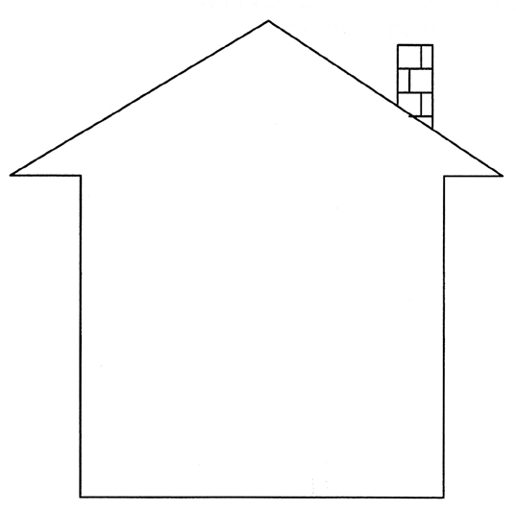
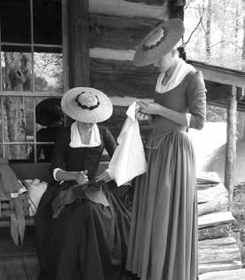
Look inside the Logan Log House. Draw the items you see inside the tavern.
Stop and imagine what life would be like for people working and visiting when it was the Black Swan Tavern. What would be going on? What sounds would you hear? What would you see? Use your imagination.

More Fun

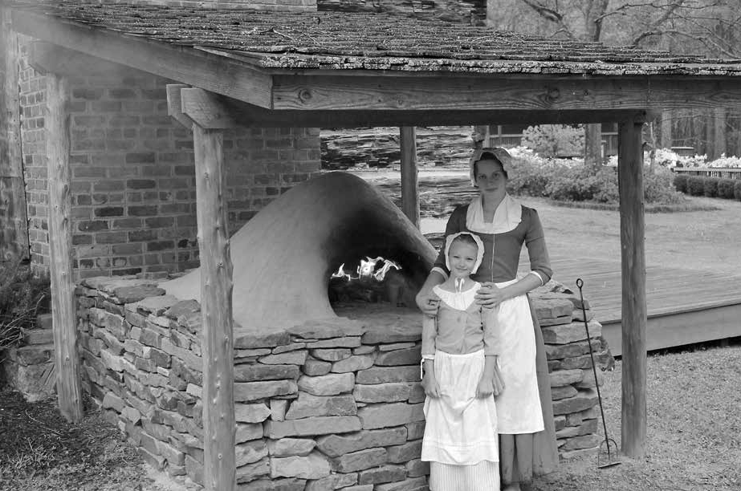

Activities!
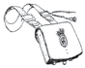
Difficulty Level:

The Mystery at Ninety Six

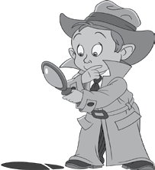

Ninety Six is full of clues to help you learn about the site.
Put these clues together to solve the riddles.

This is a device used for punishment by public humiliation.
It has hinged wood boards that form holes through the head and arms. The boards were locked together to secure the captive.
Often set up in the market places, but here at Ninety Six National Historic Site it is set up near the Logan Log House.

1. What am I?
*
This was the heart of the British defense during the Siege of 1781.
It had different obstacles in the way, like a deep ditch, sharpened stakes midway up the outer wall, and sandbags to protect the defenders from being shot.
It is in the shape of something that is bright in the sky.

2. What am I?

*
Decades of travel cut this road to its present depth.
Seven miles to the northeast, it crossed the Saluda River at Island Ford and joined roads leading to Charlotte, NC and Camden, SC.

3. What am I?

*
This is the town that was formed when people started drifting back to the area of Ninety Six in the 1780’s.
The people wanted this town to be a center for learning. The town was named after a great English university.
An epidemic swept through the town in 1815.

4. What am I?

*

The Native American tribe that lived in the Ninety Six Region had an important trading village called Keowee.
They hunted different wild game to eat, such as turkey and deer.

5. Who are we?

*
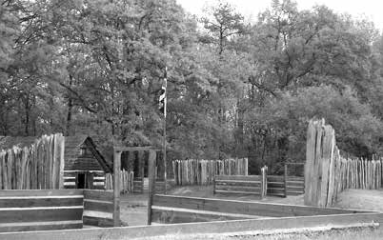
This was built around the farm of James Holmes, an active loyalist.
It guarded the Spring Branch, the main water supply for the village.

6. What am I?

*
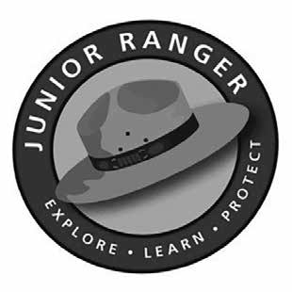
Use the letters with the asterisk (*) to discover the answer to the following:

I am a Ninety Six National Historic Site Junior __ __ __ __ __ __.

Answer Key is on Page 28

Difficulty Level:

The Revolutionary War Soldiers Word Scramble

Unscramble these words from the text on page 17.
  - FIMNORU

  - NNILE

  - GRETIMNE

  - SMKUTE

  - ESWTIK

  - EEHCBERS

  - ETNCNEA

  - NBYOAET

Answer Key is on Page 28

*Look at the mannequins in the museum exhibit to see what people wore during the time of the settlement and Siege of Ninety Six.*

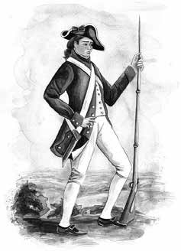
What would a soldier wear during the Revolutionary War?
The army would give soldiers the clothes and equipment they needed, but there wasn’t always enough to go around. If a shipment of garments were given to the soldiers, sometimes there wouldn’t be enough so some had to go without.

The clothes a Revolutionary War soldier would receive were:
- A shirt, usually heavy linen
- Breeches or overalls, linen or wool knee pants
- Weskit (another name for a waistcoat or vest)
- Hand-knit woolen socks
- Shoes that could fit both the left and right foot because they were
made without a left or right
- A three cornered hat called “cocked hats” that were made of black felt.
A Revolutionary War soldier would also receive a regimental coat. The coats were different colors depending on the regiment to which the soldier belonged. The different coats helped men recognize different regiments and armies. In some battles, men who were not given a regimental coat wore hunting frocks. Frocks were a loose outer coat with fringe. These hunting frocks were homespun and worn on the frontier. Many soldiers wearing hunting frocks would dye them specific colors to create a uniform. Hunting frocks were also used to do camp duties so that the soldiers wouldn’t ruin their regimental coats.

Some equipment items a Revolutionary War soldier would receive were:
- A flintlock musket that fired lead round balls but wasn’t very accurate.
- A bayonet, which is a long knife-like blade attached to the end of
a musket.
- A cartridge box to carry ammunition.
- A canteen to carry water that was usually round and made of wood
or tin.
- A haversack to carry food and small items. The haversack was a cloth bag with a three-button flap and a strap that was worn over the shoulder.
- A knapsack made of linen and painted to make it waterproof. A knapsack carried a soldier’s extra personal items.

Difficulty Level:

Match the Animals

See if you can match each of these animals living at Ninety Six National Historic Site with its name on the list below.
Baby animals have different names than adults. Draw a line to connect each of the animals with the name for its young.

Deer

Ant

Turkey

Owl

Squirrel

Frog
Antling

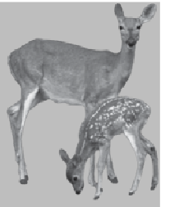
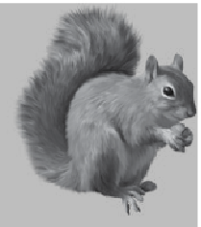
Tadpole

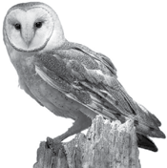
Fawn

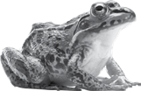Drey

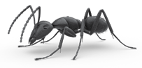
Poult

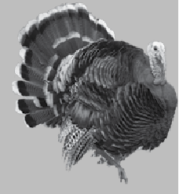
Owlet

Difficulty Level:
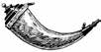
The Star Fort Maze
Finish Here
Start Here
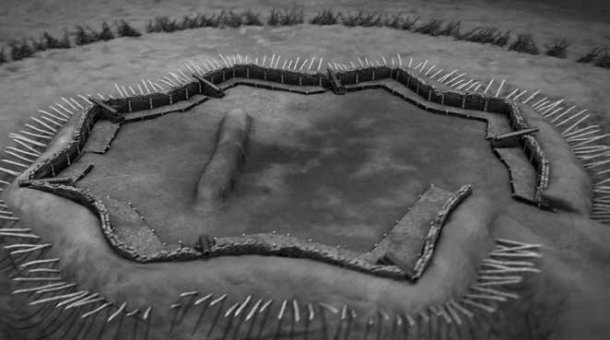
The Star Fort that you can see while walking the historic trail is an original earthwork from the Revolutionary War. It was constructed in 1781 by Loyalists and slaves. The Star Fort was the heart of the British defense. Today very few earthworks still remain from the Revolutionary War.

Difficulty Level:

Local Battlefield Picture Clues

The American Revolution was a war between the American colonies and Great Britain that lasted from 1775 to 1783. This war led to the formation of the independent United States of America. During the American Revolution, the Southern Campaign was Britain’s plan to control the Southern colonies.

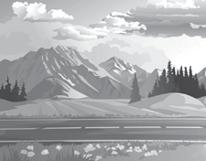
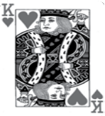Look at the picture clues to sound out the names of the other Revolutionary War national park areas in the region. These national park areas were battlefields during the Revolutionary War.

+
s National Military Park

This National Military Park remembers an important victory by American Patriots over American Loyalists during the Southern Campaign of the Revolutionary War. The battle was fought on October 7, 1780 and it destroyed the left wing of Cornwallis’ army. The victory stopped the British advance into North Carolina, forced General Cornwallis to retreat into South Carolina, and gave General Nathanael Greene the chance to reorganize the American Army.

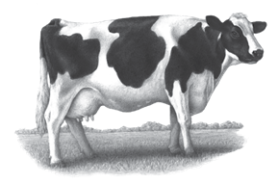

+
National Battlefield

A pasturing area at the time of the battle, this Revolutionary War site honors the place where Daniel Morgan and his army defeated Banastre Tarleton’s British army. Morgan’s army used a classic military tactic known as a double envelopment, to completely surround and destroy Tarleton’s troops.

(opposite of less) s +

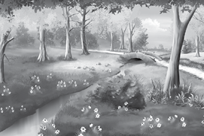
National Battlefield

This spectacular American victory prevented British control of the colony and greatly influenced North Carolina to be the first colony to vote for independence. This battle, coupled with the patriot victory at the battle at Sullivans Island near Charleston, SC a few months later, encouraged the 13 colonies to declare independence on July 4, 1776.

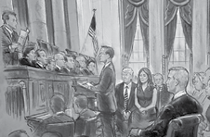

Fish use their to breathe water + 4d +
National Military Park

This battle was fought on March 15, 1781, and was one of the largest, most hotly contested actions of the Revolutionary War’s climactic Southern Campaign. Major General Nathanael Greene, defending the ground with an army of almost 4,500 American militia and Continentals, was strategically beaten by a smaller British army of about 1,900 veteran regulars and German allies commanded by General Charles Cornwallis. after 2-1/2 hours of powerful fighting, Cornwallis forced Greene from the field.

Answer Key is on Page 28

At Home Activity!
Ninety Six Word Jumble

Read this story about Ninety Six and the Southern Campaign.
There are eleven underlined words in the story below. After you have read the paragraph, find all the words jumbled below and circle them.
They may be hidden horizontally, vertically, or diagonally.
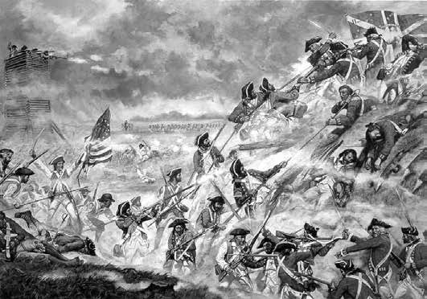
A trading village of 12 houses, a courthouse, and a jail grew on the eve of the Revolutionary War. This village was known as Ninety Six. About 100 people lived at Ninety Six, flourishing and raising families. However, 1,800 Loyalists attacked a group of Patriots that were only about one third the size of the Loyalists. They met at Ninety Six on November 19, 1775. This was the first major land battle of the American Revolution in the South. This battle lasted from November 19 - 21, 1775.

By 1778, as the war raged on, everyone realized the war was to last longer than hoped. The British plan was to control the Southern colonies and by 1780 they had almost all of South Carolina under their control.

Ninety Six Word Jumble (continued)
However, luck began to change for the Patriots when they won the battle of Kings Mountain, South Carolina. During this time, General Francis Marion was fighting Loyalists in the low country (area near the coast). also, Andrew Pickens and Thomas Sumter were waging warfare against Loyalists in the backcountry (area near the middle and upper part of South Carolina). General Nathanael Greene was the new commander of the Patriots in the South. He split his army to move more extensively through the Carolinas. General Cornwallis feared losing all of South Carolina so he sent units of British forces to Ninety Six to keep control of British territory. However, the Patriots stayed strong and won a great victory at the Battle of Cowpens in 1781.

After the battle at Cowpens, Nathanael Green’s army surrounded Ninety Six and set siege to the Loyalist’s Star Fort. Greene did this to loosen British control over the backcountry. From May 22 - June 18, 1781 Greene and his 1000 Patriot troops staged the longest siege of the Revolutionary War against 550 British troops defending the Star Fort and Ninety Six. However, Greene and his men never took the Star Fort. In July, the British abandoned Ninety Six and moved to the South Carolina coastal city of Charleston. Greene’s siege that year left Ninety Six in ruins. The departing Loyalists set fire to the buildings still standing and even tried to destroy the Star Fort.he British surrendered at Yorktown four months later. This ended the major fighting of the American Revolution.

Ninety Six Word Jumble
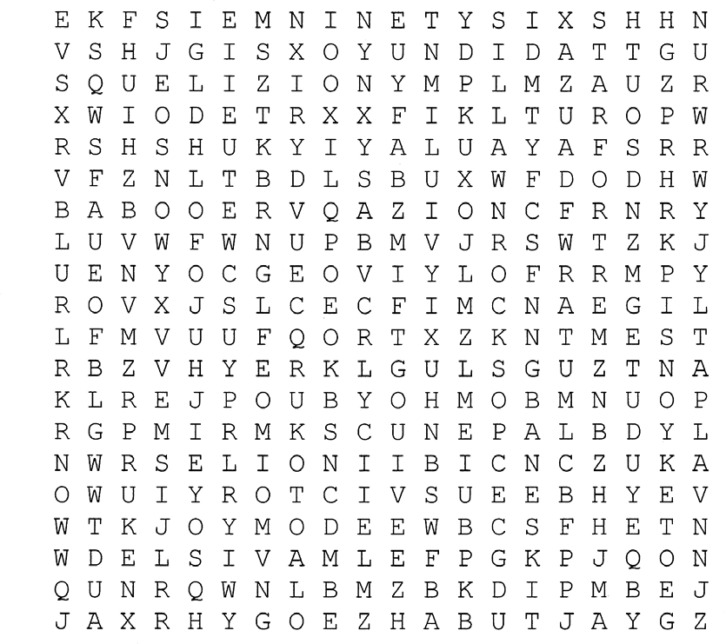

- Did you know? The Star Fort was in the shape of a star for a reason. The British used the star shape fort as a way of defense. They could fire from all corners of the star creating a crossfire effect. This was an efficient way to keep the Patriot troops from invading the Star Fort.

More Junior Ranger Fun
Now that you have earned a Junior Ranger badge from Ninety Six National Historic Site, would you like to earn one from other National Park Service sites? The National Park Service manages over 400 sites, and you can become a Junior Ranger at most of them.

South Carolina has eight (8) National Park Service sites where you can become a Junior Ranger:
  - Charles Pinckney National Historic Site
  - Congaree National Park
  - Cowpens National Battlefield
  - Fort Sumter National Monument (also Fort Moultrie)
  - Kings Mountain National Military Park
  - Ninety Six National Historic Site
  - Reconstruction Era National Monument

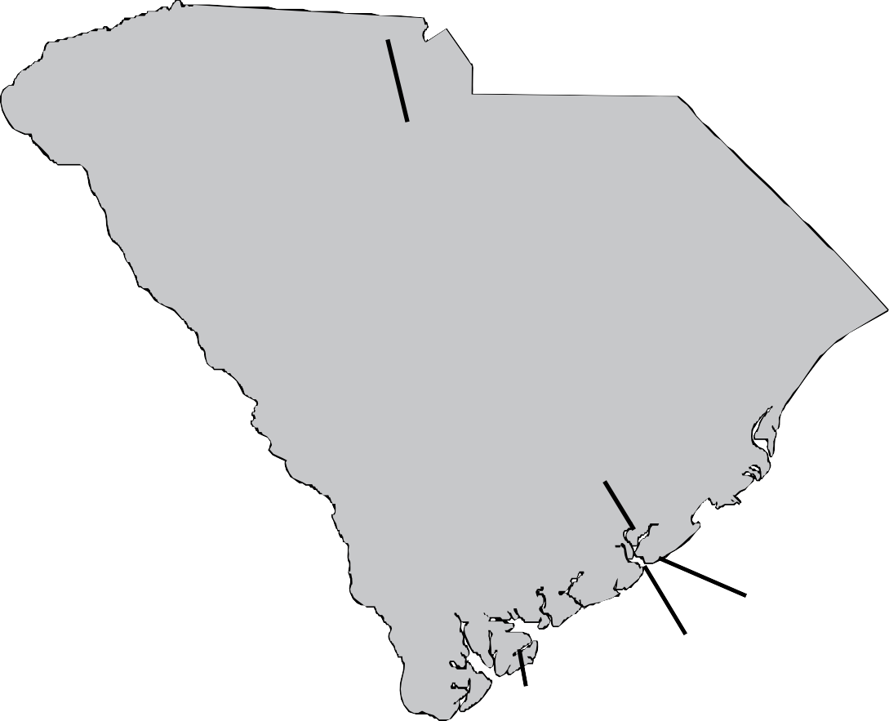
Cowpens N• B •

Kings Mountain NMP N• inety Six NHS
C•ongaree NP

SOUTH CAROLINA

Charles Pinckney NHS
••

Fort Moultrie

    - Fort Sumter NM Reconstruction Era NM

Words from Ninety Six National Historic Site

These definitions might help you complete the activities in this Junior Ranger booklet.

- Artillery – a branch of the army that specializes in using weapons like cannons.

- Backcountry – area near the middle and upper part of South Carolina.

- Bayonet – a blade adapted to fit the end of a musket and used as a weapon in close combat.

- Calvary – troops trained to fight on horseback.

- Communication Trench – (also known as a covered way) a trench that provides protected passage between the rear and the front lines of a defensive position.

- Conservation – the protection, preservation, management, or restoration of wildlife and of natural resources such as forests, soil, and water.

- Continentals – a Patriot soldier in the American Revolution. The government provides his uniforms, weapons, training, and pay.

- Freedom – liberty of a person or group of people from oppression.

- Fort – a fortified place or position stationed with troops.

- Garrison – a military post.

- Independence – freedom from control or influence of others. This was the successful ending to the American Revolution.

- Lowcountry – area near the coast of South Carolina.

- Loyalist – one who maintains loyalty to an established government, political party, or sovereign, especially during war or revolutionary change.

- Militia – an army of regular citizens rather than professionals or paid soldiers. The militia is not part of the regular army and is called in for service when there is an emergency.

- Musket – a muzzle loading shoulder gun with a long barrel. Often fitted with a bayonet at the end. Muskets were used from the 16th into the 19th century.

- Patriot – one who loves, supports, and defends one’s country.

- Pillory – a wooden framework on a post, with holes for the head and hands, in which offenders were formally locked to be exposed to public scorn as punishment.

- Predator – an animal that lives by preying on others.

- Prey – any creature hunted or caught for food: to “prey upon” something means to hunt, catch, and eat it.

- Rifle – a firearm with spiral grooves within the gun barrel to make a more accurate shot than a musket.

- Saber – a heavy cavalry sword with a one-edged slightly curved blade.

- Sappers – trench diggers. The trench diggers included men from the patriot army and slaves borrowed from nearby farms.

- Siege – the surrounding and blockading of a city, town, or fortress, by an army attempting to capture it.

- Stockade – a defense barrier made of strong posts or timbers placed upright and side by side into the ground.

- Tory (Loyalist) – a supporter of traditional and social institutions against the forces of reform; a political conservative.

- Whigs – a supporter of the war against England during the American Revolution.

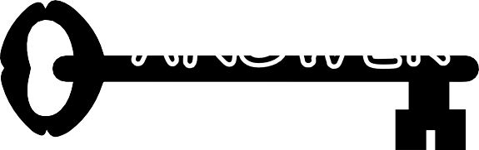
ANSWER

Answers to The Mystery at Ninety Six
  - Pillory
  - Cherokee
  - Stockade Fort
  - Cambridge
  - Star Fort
  - Island Ford Road

Answers to the Revolutionary War Soldiers Word Scramble
- Uniform
- Linen
- Regiment
- Musket
- Weskit
- Breeches
- Canteen
- Bayonet

Answers to Local Battlefield Picture Clues Kings Mountain National Military Park Cowpens National Battlefield
Moores Creek National Battlefield Guilford Courthouse National Military Park

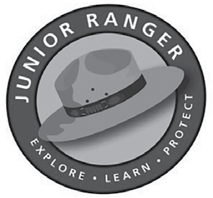

Junior Ranger Pledge
I am proud to be a Junior Ranger.
Wherever I go, I will keep exploring and learning about the nature and the history that surrounds me.
I will respect wildlife and their homes, and continue to learn about other people and their lives.
I will protect other national parks for generations of other Junior Rangers to come.

Signature:

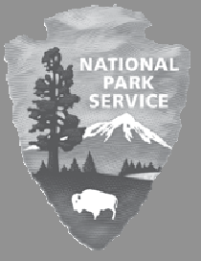

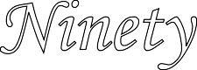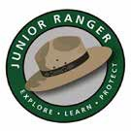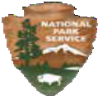

Ninety Six National Historic Site
Junior Ranger Certificate
This certificate is awarded to

by the National Park Service, U.S. Department of the Interior
For completing requirements of the
Ninety Six National Historic Site Junior Ranger Program

Park Ranger Date

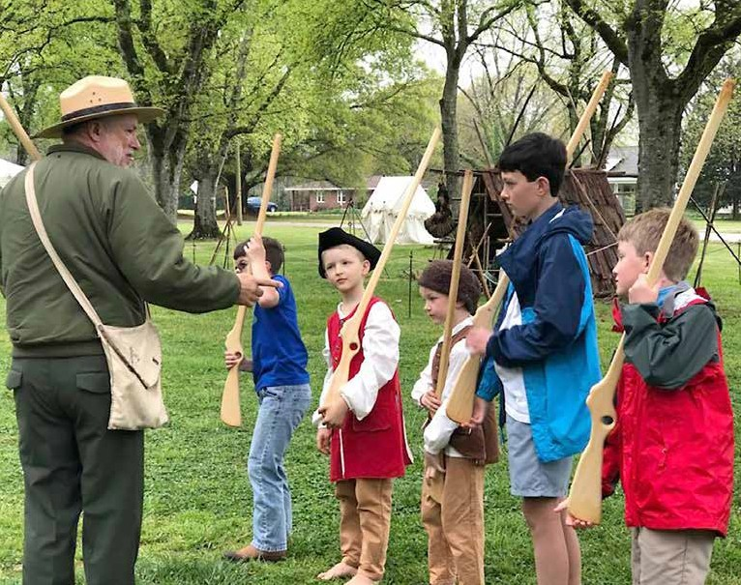

Thank you for your interest in our
Junior Ranger Program!

Mailing Address:
1103 Hwy 248 S
Ninety Six, SC 29666 (864) 543-4068
http://www.nps.gov/nisi

You can also visit us on Facebook at www.facebook.com/NinetySixNPS. Be sure to tag us when doing your Junior Ranger book at the park!

