ERA 101 A Short Syllabus
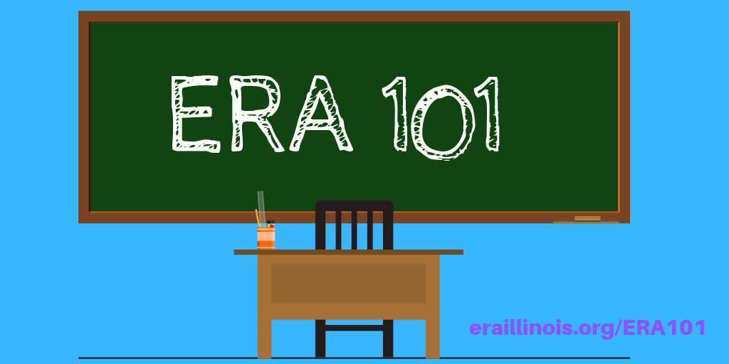
eraillinois.org
ERA 101: a short syllabus
2-3 minutes

A quick overview:
- Scholastic Junior's 5-Minute Guide to the ERA [printable version]
- Teen Vouge's The History of the Equal Rights Amendment, Explained
- ​Reader's Digest's 16 Facts and Figures About the Equal Rights Amendment
For the visual learners:
- Politico's Explainer Why hasn't the Equal Rights Amendment been ratified?
- Buzzfeed's video on Why Women Aren't Equal (10 mins)
- John Oliver's take on Last Week Tonight (15 min)
- The documentary titled Equal Means Equal is available to watch on iTunes and Amazon. Fair warning, it will piss you off. (90mins)
- Senate Staff briefing hosted by Senators Cardin and Murkowski in July 2019 (75 min)
Podcasts for those on the go:
- US Constitution Center episode "We the People: Can the Equal Rights Amendment be Revived?"
- Unladylike's episode "How to Stop Getting Screwed in the SCOTUS"
Take a Deeper Dive:
- Concise description of the legal arguments around the ERA by Professor Jessica Neuwirth (June 2019).
- ERA "myths" are debunked in this newsletter article from the Illinois State Bar Association (November 2015).
- The Congressional Research Service (CRS) issued a report on the viability of the three state strategy. It's a good starting point on the history of the Equal Rights Amendment and the Three-State Strategy (July 2018). ​
- For a legal perspective on the Equal Rights Amendment, academic Sarah M. Stephens gives a throughout overview of strategies to achieve equality in the Brooklyn Law Review (2015).
- For the nightstand, buy Equal Means Equal, a book by Jessica Neuwirth (2015).
Lastly, understand what the opposition is saying:
- Eagle Forum (note the family is fighting over the legacy of this organization and split into two groups. The splinter group is Phyllis Shafly's Eagles)
- Federalist Society
- Concerned Women for America​​

