Black Panther Film Movie Companion for Middle Grades

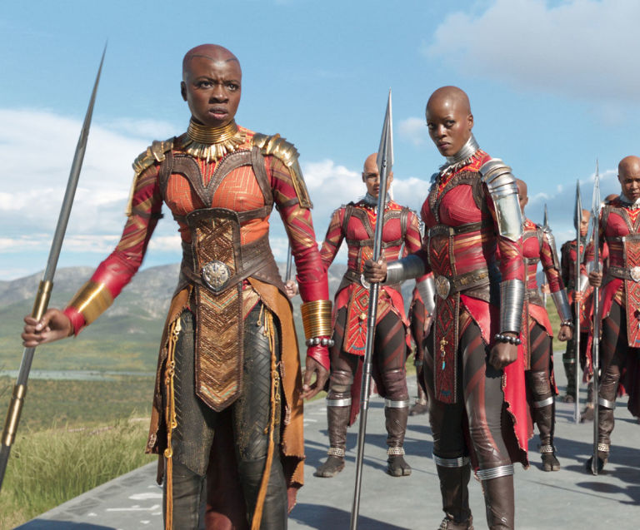

Tess Raser

Grades: 5th-8th (works for high school too)

This curriculum is designed for students who are seeing Black Panther, as a means to having them engage more critically and thoughtfully with the film. The curriculum assumes that students, like mine, have previous experience of studying the African continent, its diversity and colonialism.

Table of Contents

Pre-Viewing:
- The Legacy of Colonialism in the African Continent
  - What is Colonialism?
  - When did it occur in Africa?
  - How did it affect the continent?
  - Colonialism’s long lasting effects.
- The Legacy of Slavery in the Americas
  - What was the Transatlantic slave trade?
  - How did it affect Black people in the United States?
  - Slavery’s legacy today
- Global Anti-Blackness
  - What is anti-blackness?
- Afrofuturism
  - What is Afrofuturism?
- African Cultural Representation in Black Panther
  - What cultures will be referenced in this film?

Post-Viewing:

- T’Challa---A Character Analysis
  - Character attributes/Interpretation
- Killmonger---A Character Analysis
  - Character attributes/Interpretation
- Shuri----A Character Analysis
  - Character attributes/Interpretation
- Black Feminism---the role of Black women in Wakanda
  - What was the role of Black women in Wakanda compared to their role in our society?
- What does Wakanda represent--A Debate
  - Black elitism or Afrofuturistic Possibility?
VI. Bonus: Who are you in Wakanda?

- The Legacy of Colonialism on the African Continent
Standards:
CCSS. ELA-Literacy. RH 6-8.7 Integrate visual information (i.e. Charts or maps) with other information in print and digital texts.
D2. HIS.1. 6-8 Analyze connections among events and developments in broader historical contexts.
D2. His.14.6-8 Explain multiple causes and effects of events and developments in the past.
Objective:
- Students will be able to define colonialism.
- SWBAT understand colonialism’s effects on the African continent.
- SWBAT tell what empires colonized Africa.
- SWBAT understand the ways in which colonialism still has an effect on African nations.

Materials:
- Projector/Smartboard to connect to YouTube.
- Candy or some sort of snack
- Colonialism handout

Hook:
- Distribute some sort of candy or snack to a student.
- Tell them not to eat it and that they’ll be able to soon because it’s their snack. They own it, and it has always been there.
- Introduce that today we’ll be discussing colonialism and its effects on Africa.
- Then before beginning, subtly wander over to the student who you have candy to, and subtly eat the food, and tell the student to stand up and take their chair to sit in.
- Pause for the student’s reaction. Ask the class what I just did and was it justified? Note reactions on white board, and note that at a very basic and less violent level, that was a way of looking at colonialism.

Define:
Put definitions of these words on the board:

Colony---a group of people from one country who build a settlement in another territory, or land. They claim the new land for the original country. The settlement itself is also called a colony.

Colonization-----the action or process of settling among and establishing control over the indigenous people of an area. The occupation and control of one nation by another. European nations have colonized many areas of the world, including North America.

Display: Display African Languages Map on the projector:
-Ask the class, “By looking at the languages listed, which European countries do you expect were involved in colonizing Africa?
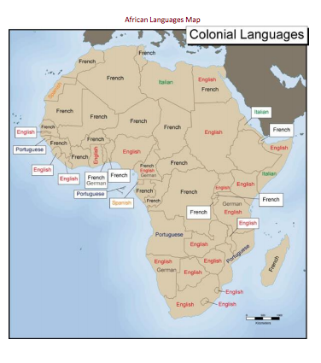

Explore: Direct students to Exploring Africa link on tech with Colonial Exploration Reading Guide:
http://exploringafrica.matrix.msu.edu/colonial-exploration-and-conquest-in-africa-explore/
http://exploringafrica.matrix.msu.edu/the-practice-and-legacy-of-colonialism-expand/

Colonial Exploration Reading Guide

- Name and briefly describe three causes of European colonization in Africa?

2. What was the Treaty of Berlin?

3. By _______________almost_______________% of Africa was under European control.

4. Consider the Europeans that were drawing colonial borders in Africa. What factors did they have to consider? What were their interests as a nation? How might these interests have conflicted with people in Africa and with other European nations? What problems may this have caused?

5. How do you think the changes brought on from European Colonial Rule affected what Africa is like today?

Show video: https://www.youtube.com/watch?v=Pw12KGSj53k

II. The Legacy of Slavery in the United States

Procedure:
- Students will go thru this reading from Exploring Africa and analyze maps to understand the Atlantic Slave Trade.
- Students will then do an activity in which they trace incarceration from the time of slavery to the present.

The Beginnings of the Atlantic Slave Trade
Europeans had become involved in this trade and developed a strong demand for gold in their economy. However, Europeans were dependent on “middle-men” who would bring gold from the Kingdoms of West Africa across the Sahara Desert. In the 1400s, Prince Henry of Portugal began an initiative to seek out direct sea routes to gain access to the gold trade in West Africa, as well as trade in Asia. In the fifteenth century, European countries were seeking trade routes with Asia, particularly the spice islands of south-east Asia. Just as Spain sponsored Christopher Columbus in his attempt to find a sea route to Asia by sailing to the west, Prince Henry and the Portuguese hoped to find a sea route to Asia by sailing around the coast of Africa. What began as a quest for trade in gold and spices, ended up becoming a trade network exporting African slaves, which would continue for more than 400 years.
The first slaves brought to Portugal came in 1444 from Northern Mauritania. From Mauritania, the Portuguese moved their way down the western coast of Africa, establishing contact all the way down to the Cape of Good Hope and around to the other side of Africa. Through these contacts, the Portuguese initiated trade relations that grew into the Atlantic Slave Trade. Portugal was the first of a number of European nations who became involved in the Atlantic Slave Trade. The Dutch, French, Spanish, and British soon followed in their footsteps. See the map below to find some of the exploration routes that the Portuguese followed.
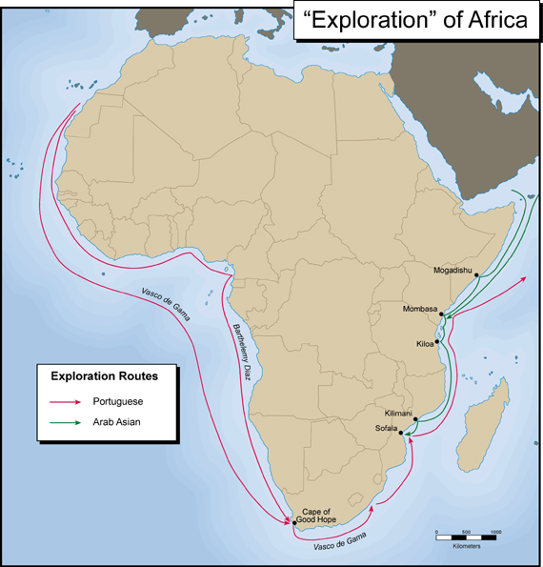

As an example of what transpired through this period of Portuguese exploration, we will briefly look at the Kongo (Congo) Kingdom. Remember that this is one of many examples and does not represent what happened in every instance. The interaction of European powers and Africans varied from region to region. In this example, you will see that what may have seemed like a diplomatic exchange of citizens in the beginning, grew into a system of slave trade that devastated the Kongo Kingdom. In 1483, the Portuguese began a long-term relationship with the Kongo Kingdom (see map below to locate the Kongo Kingdom.) Portuguese explorer Diogo Co sailed via the Atlantic Ocean down into the mouth of the Congo River. Upon reaching the Kongo Kingdom, he took Kongo emissaries back with him to Portugal, who later returned to Africa with European soldiers, priests, and goods. This was the beginning of a strong trade relationship with the Kongo that exported slaves and ivory in exchange for European luxury goods and guns.

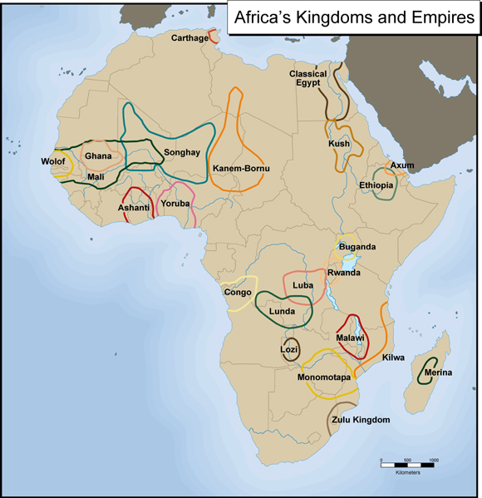

Although historians know that slavery existed in some places on the African continent prior to the Atlantic Slave Trade, the ways in which African slavery compared to and interacted with the exportation of African slaves across the Atlantic remains a topic of much discussion and debate. The nature and extent of slavery in Africa before the Atlantic Slave Trade is difficult to know. Many historians suggest that slavery was practiced in different areas in Africa, but was not the same as “chattel slavery” -seeing human beings as mere property-, which was practiced in the Americas. For example, slaves in some West African societies filled different positions in society, including positions of important responsibility; they were not restricted to hard labor. It is not easily determined to what extent the Atlantic Slave Trade fueled and even transformed the practice of slavery within Africa. Certainly this varied from region to region, and there are many regions within Africa where slavery was not even practiced. However, there is no doubt that the Atlantic Slave Trade brought dramatic changes on a global scale throughout the African continent as well as the Americas.
In the case of the Kongo Kingdom, a form of slavery existed prior to Portuguese contact, which the Portuguese tapped into. However, the Portuguese had a dramatic impact on the Kongo Kingdom through pressure to increase raids of neighboring peoples to capture for the Atlantic Slave Trade and the exportation of large numbers of Kongolese over many years. The Atlantic Slave Trade fueled violence in the region, removed productive workers from the Kongo, and encouraged an economy built around slavery. Over time, the Kongo Kingdom became weaker and more dependent on Portuguese assistance.

How the Atlantic Slave Trade Operated
The Atlantic Slave Trade essentially worked like a triangle between Africa, Europe, and the Americas. If you look at the map of the Atlantic slave trade, you will see how the route worked. Trade goods, such as guns and textiles were sent out of Europe and traded in Africa for slaves. The slaves were crammed into ships that crossed the Atlantic in order to provide labor for large plantations in North and South America, which were growing cotton, sugar cane, and tobacco. These regions of North and South America were European colonies for much of the Atlantic Slave trade and served to provide raw materials to Europe for manufacturing.
On the map below, you can see that slaves were sent from Africa not only to North America, but also to the islands of the Caribbean and the east coast of South America. Actually, the smallest number of slaves was exported to North America, as compared to the Caribbean and South America. About millions of slaves (out of 15 million total) were sent to the southern part of the United States. Approximately half of the total slaves sent to the Americas went to the Caribbean, and about a third of them went to Brazil. Indeed, as a legacy of the slave trade, Brazil has the largest population of people of African decent outside of Africa. However, the population of slaves in the United States grew at a higher rate than it did in these other regions. Consequently, the African-American population in the United States today is second only to Brazil in the New World.
To speak about the degree of human suffering that took place during the Atlantic Slave Trade is not an easy task. Slaves were kept living in abominable conditions in dungeon fortresses along the coast of western Africa until the time that they were sent out to sea on large boats headed for the Americas. Both the slave forts and slave ships kept people in dark, dirty rooms with little to eat or drink and no room to move. They were kept in chains and left to lie on their backs on slave ships while crossing the Atlantic Ocean. This long and treacherous journey has become known as the “Middle Passage.” Historians estimate that as many as 20% died while crossing the ocean, not to mention those who died in the slave forts while still in Africa. To learn more about the slave forts, visit the website: http://webworld.unesco.org/goree/, which will tell you about the Island of Goree, where many slaves were kept before being shipped off to the Americas. This and many other former slave forts can be visited today in West Africa to learn about the history of the slave trade.
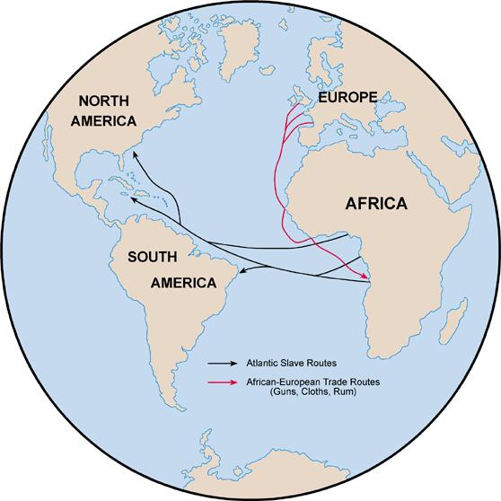

The End of the Atlantic Slave Trade and Its Impact on Africa
A number of factors contributed to ending the Atlantic Slave Trade officially in the early 19th century, after it had continued for over 400 years. Among these was a growing public revulsion against the slave trade. One important person in bringing about this change was Olaudah Equiano. Olaudah Equiano was born in present-day Nigeria and taken to the Americas as a slave. During his life, he was able to buy his freedom (a rare occurrence) and wrote about his experience being captured and sold into slavery. His book was published in 1789 and read throughout the Americas and Europe in multiple languages. His writing had a profound effect on public opinion on the slave trade.
In addition between 1801 and 1803, there had been a successful slave revolt in the Caribbean island nation of Haiti, which shook people throughout the Americas to realize that this system of slavery could be challenged and overthrown. Under the leadership of Toussaint Louverture, an ex-slave in 1804, Haiti became the first black republic in the world and the first country in the Western Hemisphere to abolish slavery. To learn more about the history of Haiti, explore the website: http://www.nationsonline.org/oneworld/History/Haiti-history.htm
Finally, the Industrial Revolution in Europe and North America, which occurred simultaneously with the Atlantic Slave Trade, was fueling a growing demand for free rather than servile labor. In the early years of the Industrial Revolution, cheap raw materials, such as cotton, produced by slave labor in the Americas were essential, but by the 19th century continued industrial expansion was dependent on a flexible and mobile labor force. Consequently, many European and American industrialists who supported the slave trade in the 18th century changed their minds when slavery was no longer an economic benefit.
In 1807, Britain became the first European nation to ban the slave trade. France, Holland, and the United States soon thereafter passed legislation banning the slave trade. However, since Spain and Portugal did not follow this example, African slaves continued to be sent to countries in South America until near the end of the 19th century.
In an attempt to stop the slave trade, Britain dispatched war ships to intercept slave ships off the west coast of Africa. When intercepted, the freed slaves were often sent to Liberia (“Liberty”) and Sierra Leone (capital city named Freetown) in West Africa, which were established by US and British anti-slavers as havens for freed slaves.
In spite of the effort to end the slave trade, slavery continued to be practiced in the Americas. The British freed slaves in their Caribbean colonies in 1833. The French abolished slavery in their American colonies soon thereafter. Slavery was not abolished in the United States until 1864. Cuba and Brazil were the last countries in the Americas to abolish the practice of slavery in the late 19th century.
The Atlantic Slave Trade had enormous negative effects on the continent of Africa. As was mentioned above in regards to the Kongo Kingdom, many parts of Africa suffered from an increase in violence, drain of people, and an economy increasingly reliant on slavery. Over four hundred years of slave trade had transformed the African Continent from coastal regions (where most of the trading with Europeans took place) all the way to the interior of Africa (where many slaves were captured to be sold.) Despite the tremendous consequences of the Atlantic Slave Trade on Africa, Africans still continued to make important progress during this time in areas such as literacy, metal working, and textile production. However, there is no doubt that the Atlantic Slave Trade changed the face of the earth in many ways and presented a huge challenge to Africa in trying to recover from this brutal period of her history.
Reading Quiz
- Draw and label arrows showing the flow of goods from Europe to Africa as well as the flow of slaves from Africa to various regions of the Americas.
- Show the routes that some of the Portuguese explorers took when seeking trade routes with Africa.
- Locate the Kongo (Congo) Kingdom on the map below.
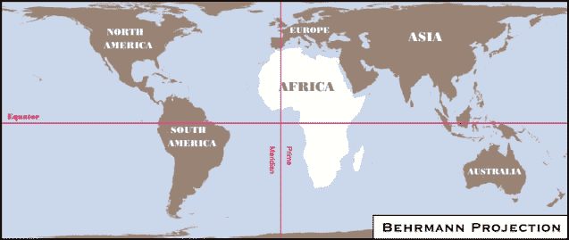

Images/Multimedia Links:

- http://slaveryimages.org/
- http://www.slavevoyages.org/

*In this next lesson students will understand one of the lasting impacts of slavery thru studying the prison industrial complex through music*

We Want Freedom For All Black and Oppressed People Now Held in U.S. Federal, State, County, City and Military Prisons and Jails.
Objectives
- Students will understand the ways in which prison is connected to institutionalized slavery.
- Students through music, will understand the conditions of plantation slavery and prison slavery.
- “We believe that the many Black and poor oppressed people now held in US prisons and jails have not received fair and impartial trials under a racist and fascist judicial system and should be free from incarceration. We believe in the elimination of all wretched, inhuman penal institutions, because the masses of men and women imprisoned inside the US … are victims of oppressive conditions, which are the real cause of their imprisonment.”

Key Points
- What is abolition?
- Why do we use a word we used for ending chattel slavery to describe our work around getting rid of prisons?
- How can and should we connect with our community members that are locked away?

Main Idea
-The 13th amendment only ended slavery for those who were not convicted of a crime. We still have a system designed to dehumanize and keep Black people down--mass incarceration. We understand the horrors of chattel slavery, and we must see that incarceration is just as horrific and racist.

-Black musicians have always beautifully told our stories, struggles and pushed us through their. Today, we’ll explore how through a musical journey in abolition music.

Materials
- Projector
- Projector screen
- Poster fact cards on 13th amendment, full point, abolition definition, chart of chattel slavery/chain gang imprisonment/contemporary imprisonment
- Device for playing music
- Construction paper
- Markers
- Letter writing paper

Abolition Introduction - 10 min
-Definition of Abolition is introduced and its roots during chattel slavery
-Introduce the 13th Amendment and its limits in “abolishing slavery”
-Read excerpt from Incidents in the Life of a Slave Girl and then read excerpt from Assata
-Emphasize that Incidents is an autobiographical account of chattel slavery and Assata is Assata’s account of modern day prison
-What are the similarities in Harriet Jacobs’ and Assata’s situation?

*The point of this is to highlight initial similarities in both types of slavery and to challenge the myth that slavery was abolished. Young people believe, and are indoctrinated to believe, always that prison is for those who are bad. This will be a hard connection for them to make.

A journey Through Abolition Music - 20 min
- We will go on a journey through incarceration through music. There will be different activities with the songs along the way, and we’ll discuss briefly between each era.
- Chattel Slavery: As we listen to the song selections, we’ll close our eyes reflecting on how we feel as we listen to the songs (the songs are heavy) so after both selections, we’ll process as a group.
  - Nobody Knows the Trouble I’ve Seen-Blind Boys of Alabama (0-1:04)
  - No More Auction Block for Me-Sweet Honey in the Rock (0-1:25)
- Chain Gang Era Incarceration: As we listen to the song selections, we’ll watch a slideshow of images depicting chain gang incarceration, as it is something that is less familiar to young people, yet shows the bridge from the plantation to the jail cell.
  - Po Lazarus- James Carter and the Prisoners (0-:30)
  - Chain Gang-Sam Cooke (:50-1:27)
- 1990s Start of Mass Incarceration: As we listen to the song selections, we’ll draw pictures/designs/patterns of what thoughts the music evokes.
  - Police State—Dead Prez (1:05-1:50)
  - Behind Enemy Lines-Dead Prez (1:10-2:10)
  - Clamin’ I’m a Criminal—Brand Nubian (:58-1:12/ 1:17-1:30/2:31-2:50)
- Contemporary Mass Incarceration Generation: As we listen to the song selections, of music our akerele will be more familiar with, we’ll get up and move.
  - New Slaves—Kanye West (2:10-2:24)
  - These Walls-Kendrick Lamar (3:15-4:13)

**Collective Breath**

Prison letter Writing - 25 min
- Bettina from Liberation Library will share with us, briefly, her work collecting and giving books to children who are incarcerated and their prison letter writing project.
- We will then have silent letter writing time (all Akerele and adults—so we can model our commitment and love for our people locked up too)
  - While we are writing we will listen to:
    - First, Penitentiary Philosophy by Erykah Badu to motivate us to (stay awake), lift our spirits a bit but keep us angry at prisons.
    - Second, Umi Says by Mos Def, because we’ll be feeling down, and we’ll be left with a message of loving our people through the same medium that introduced us to institutionalized harm.

Closing- 5 min
- Love is Contraband in Hell once (instead of Duty to Fight unless people object??)
  - Love is contraband in hell
Cause love is an acid
that eats away bars.

But you, me and tomorrow
Hold hands and make vows
That struggle will multiply

The hacksaw has two blades.
The shotgun has two barrels.

We are pregnant with freedom

We are a conspiracy.

-Assata (I love this poem more than anything)

Notes:
Chattel Slavery
-began even before declaration of independence in the colonies
-In the 1800s slavery was referred to as a “necessary evil” because freeing black people would have too many consequences
-called chattel because chattel means personal property of the owner and they are bought and sold as if they are commodities/a good.

chain gang
-they are chained together to perform menial or physically challenging tasks just for punishment
-mostly in southern states (some chains weighed twenty pounds)
-in 1955 was phased out nationwide. however, in clinton “get tough on crime” era in 1990s, some states reintroduced chain gangs….like Alabama in 1995

Clinton became president in 1993-2001
In 1994 Clinton signed the Violent Crime Control and Law Enforcement Act, which gave states billions in funding for new prisons, but only if states adopted truth in sentencing laws, which would reduce prisoners’ eligibility for parole. it also created mandatory life-sentences for people convicted of a third violent felony, among other punitive measures.
-by the end of clinton presidency the number of people in America’s prisons rose by nearly 60%

The Narrative of Bethany Veney: A Slave Narrative from Virginia,
"Slavery was the worst days was ever seed in the world. They was things past tellin', but I got the scars on my old body to show to this day.

“ Mostly we ate pickled pork and corn bread and peas and beans and taters. They never was as much as we needed.
"The times I hated most was pickin' cotton when the frost was on the bolls. My hands git sore and crack open and bleed. We'd have a li'l fire in the fields and iffen the ones with tender hands couldn't stand it no longer, we'd run and warm our hands a li'l bit. When I could steal a tater, I used to slip it in the ashes and when I'd run to the fire I'd take it out and eat it on the sly.”

"We was scart of Solomon and his whip, though, and he didn't like frolickin'. He didn't like for us niggers to pray, either. We never heared of no church, but us have prayin' in the cabins. We'd set on the floor and pray with our heads down low and sing low, but if Solomon heared he'd come and beat on the wall with the stock of his whip. He'd say, I'll come in there and tear the hide off you backs.' But some the old niggers tell us we got to pray to Gawd that he don't think different of the blacks and the whites. I know that Solomon is burnin' in hell today, and it pleasures me to know it.

We prays for the end of Trib'lation and the end of beatin's and for shoes that fit our feet. We prayed that us niggers could have all we wanted to eat and special for fresh meat. Some the old ones say we have to bear all, cause that all we can do. Some say they was glad to the time they's dead, cause they'd rather rot in the ground than have the beatin's. What I hated most was when they'd beat me and I didn't know what they beat me for, and I hated they strippin' me naked as the day I was born.”

III. Global Anti-Blackness

Post definition: Anti-blackness is a global phenomenon that affects people in every cultural and ethnic group. Within larger systems of structural oppression, it translates to higher rates of social ills, including poverty, unemployment, poor health outcomes, and substandard housing. We will also discuss the impact of anti-blackness in our congregations and beyond.
(modify if needed depending on your students comprehension)

- Anti-Blackness comes from the idea that black people do not get to be full people in the world as a whole.
- It’s the idea that black people are discriminated against globally---not just here in the United States.
- This is seen thru policies, black face, darker skinned people being treated worse in most societies worldwide.

Now, students will break into groups and will become experts on the article their group receives. After reading each article and discussing in groups, they will chart on chart paper: Main idea, what is the instance of anti-blackness here, where does it take place?

- Group 1----Anti-blackness in China.
  - https://thegrapevine.theroot.com/anti-blackness-goes-east-china-just-banned-hip-hop-cu-1822312323
- Group 2----Anti-blackness in Latina Music
  - https://trackrecord.net/theres-a-huge-anti-blackness-problem-in-latin-music-1821872698
- Group 3----Black face in the Netherlands
  - https://www.washingtonpost.com/news/global-opinions/wp/2017/11/28/the-netherlands-holiday-blackface-needs-to-go-once-and-for-all/?utm_term=.3cc09cf85c2c
  - https://www.irishtimes.com/life-and-style/abroad/the-controversial-christmas-tradition-of-blackface-in-the-netherlands-1.3336142
- Group 4---Anti-blackness in the Asian-American community
  - https://www.huffingtonpost.com/entry/how-asian-americans-can-stop-contributing-to-anti-blackness_us_599f0757e4b0cb7715bfd3d4
- Group 5----Skin bleaching in West Africa
  - https://www.nytimes.com/2016/11/26/fashion/skin-bleaching-south-africa-women.html

IV. Afrofuturism

Show Powerpoint:
https://docs.google.com/presentation/d/1GupmjZ65sTeiYz2zn3drZMAReNF8ObAykjAYUD8MLs4/edit?usp=sharing

Exit Ticket
Name: _____________________

- In your own words, what is Afrofuturism?

_______________________________________________________________________

________________________________________________________________________

________________________________________________________________________

2. Can you think of any examples that weren’t mentioned of Afrofuturism that you’ve seen or heard?

________________________________________________________________________

_________________________________________________________________________

_________________________________________________________________________

V. African Cultural Representation in Black Panther

These can be posted throughout the room as a Gallery Walk

Black Panther Film | African Tribe/Culture
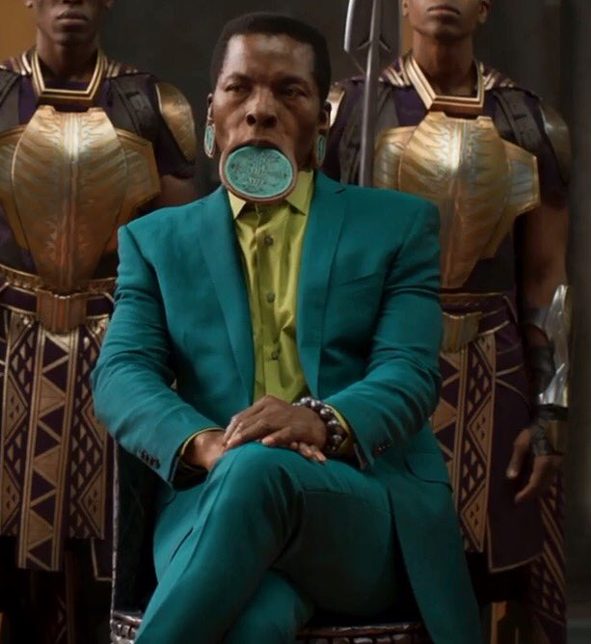 | 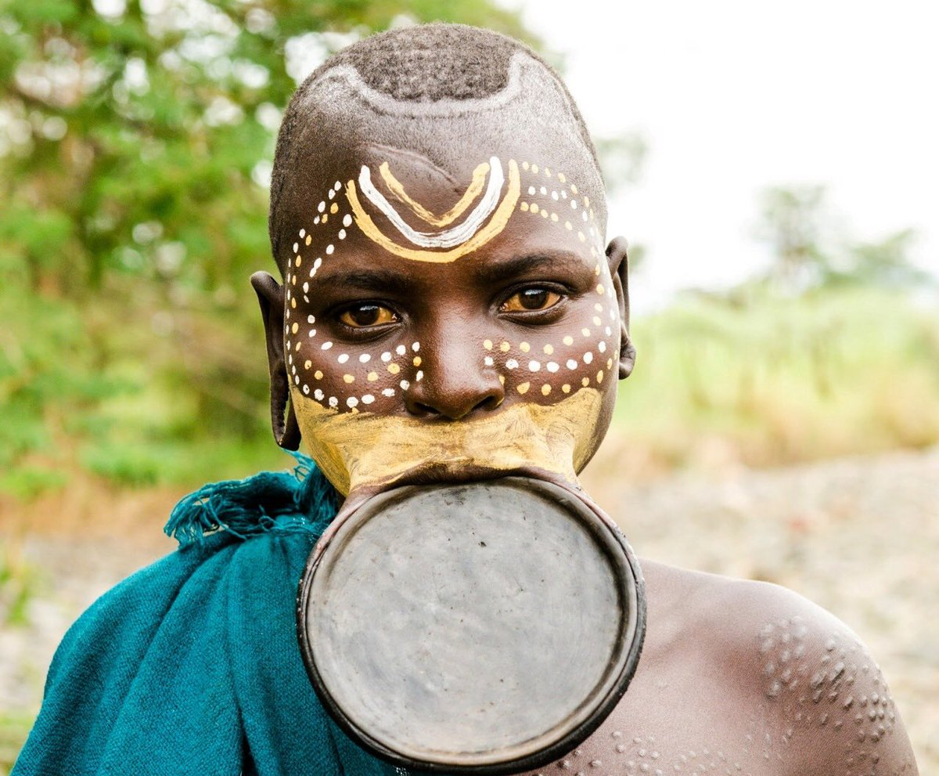Mursi and Surma lip plates---Most frequently used by Mursi and Surma in Ethiopia (East Africa)
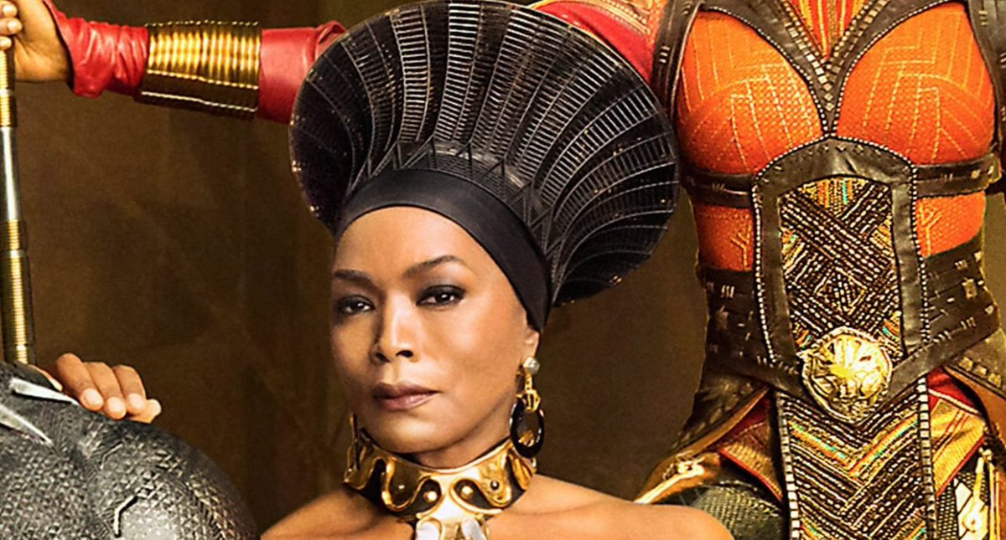 | 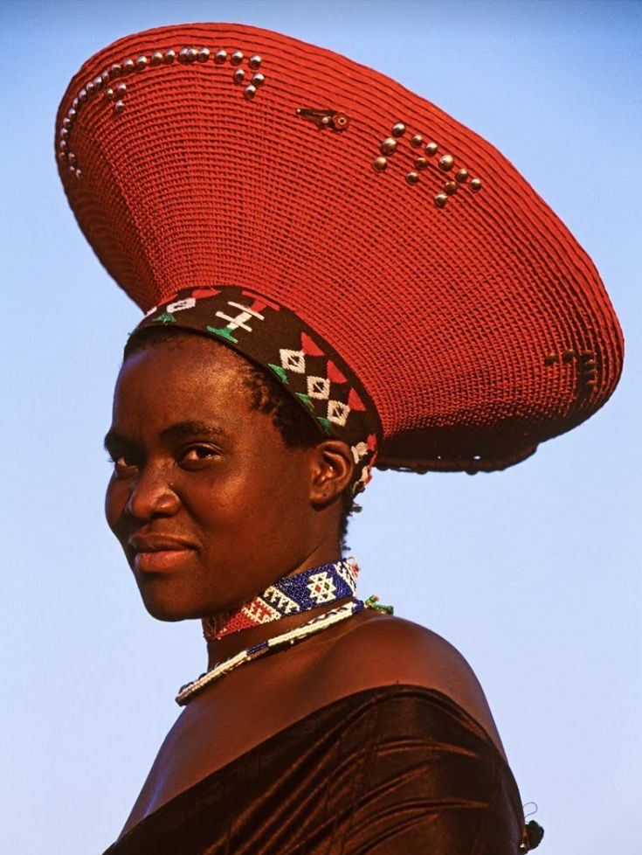Zulu headdress---worn by married women. The Zulu are an ethnic group from southern Africa.
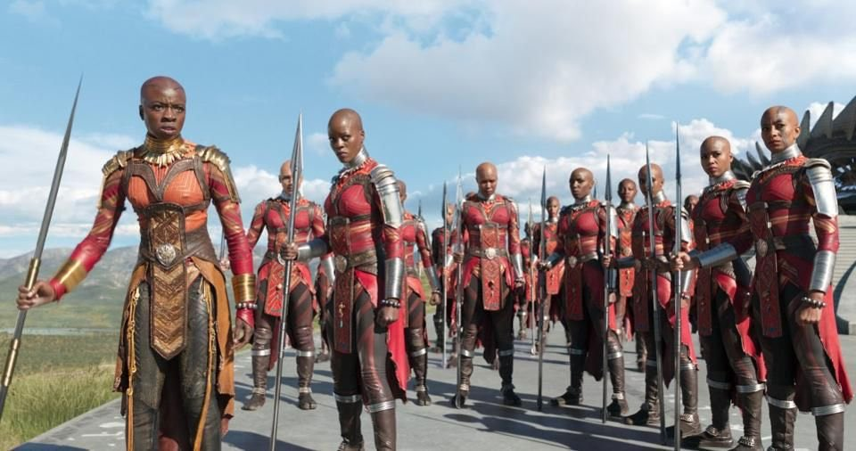 | 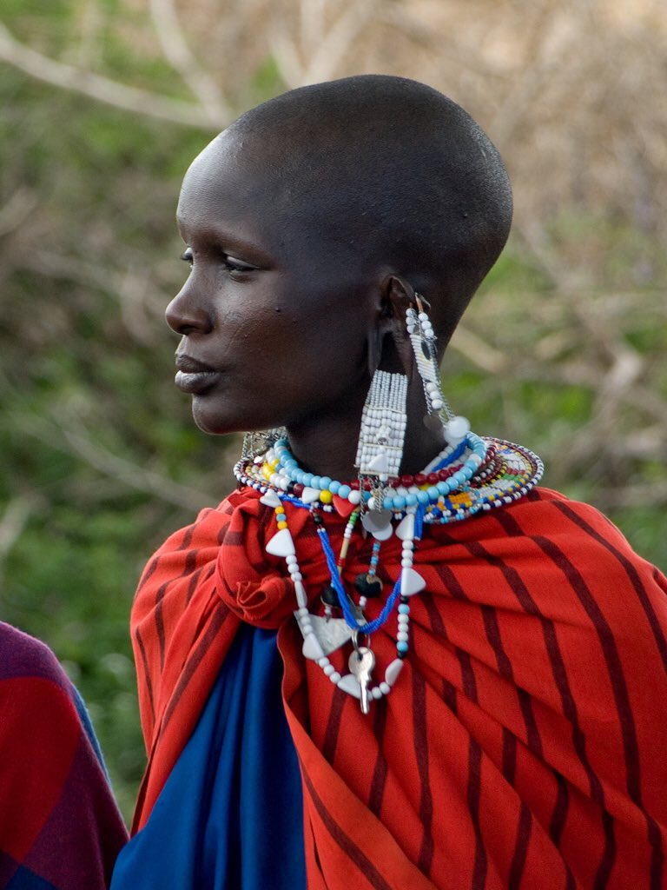  The Maasai People---from East Africa, they live in southern Kenya and northern Tanzania
 | 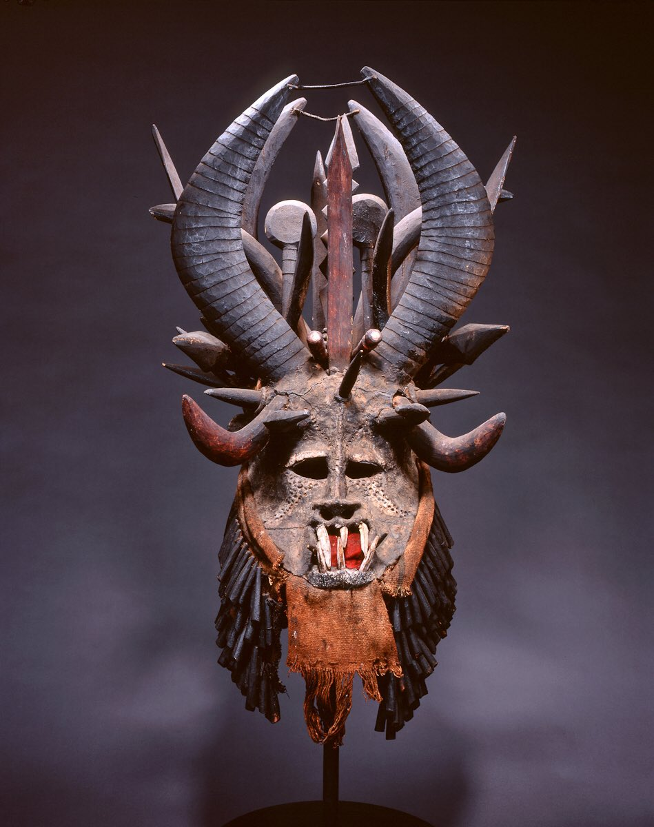  An Igbo mask, known as Mgbedike. The Igbo are from present day Nigeria.
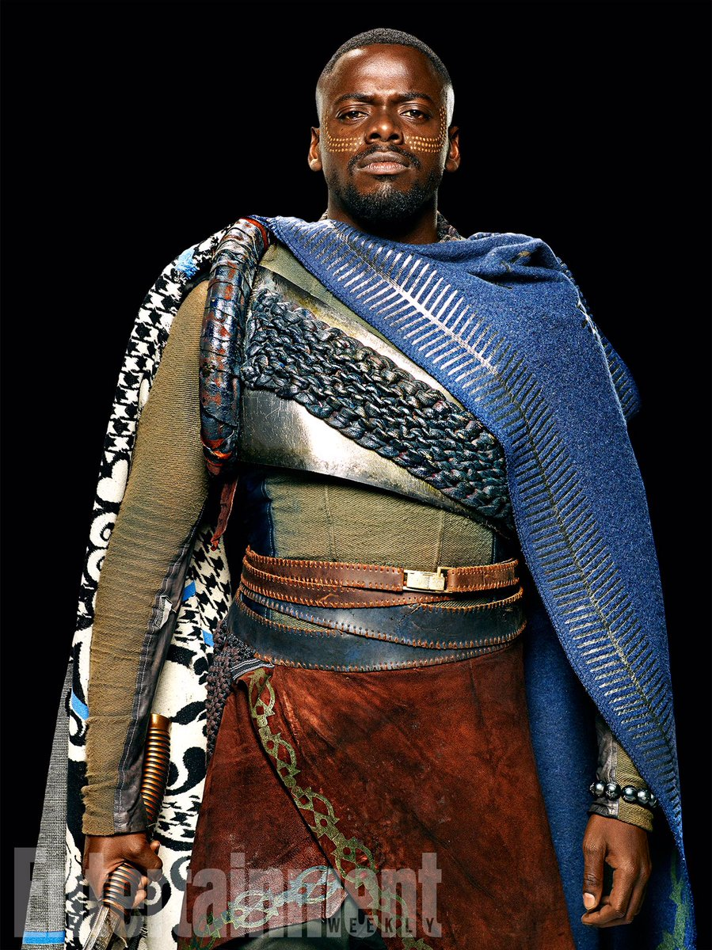 | 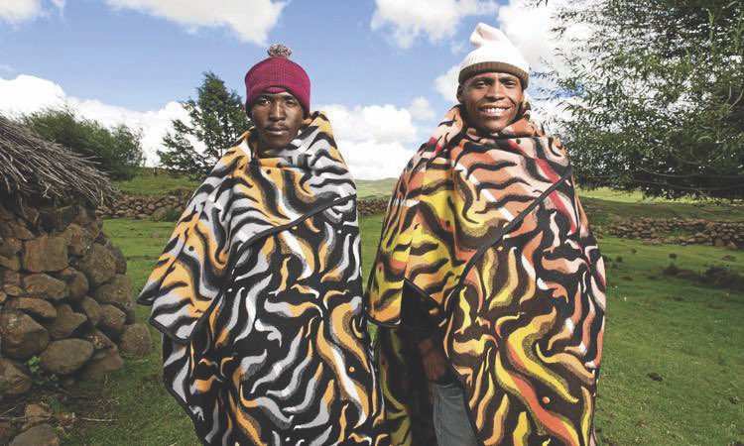  Basotho Blanket---These blankets are from Lesotho and their designs are from the Sesotho people (southern Africa)
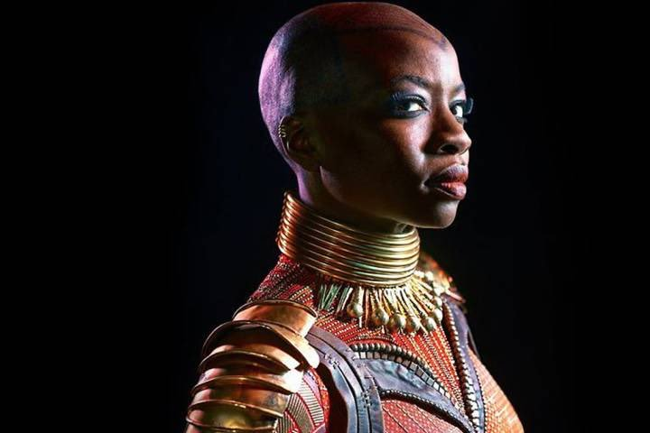 | 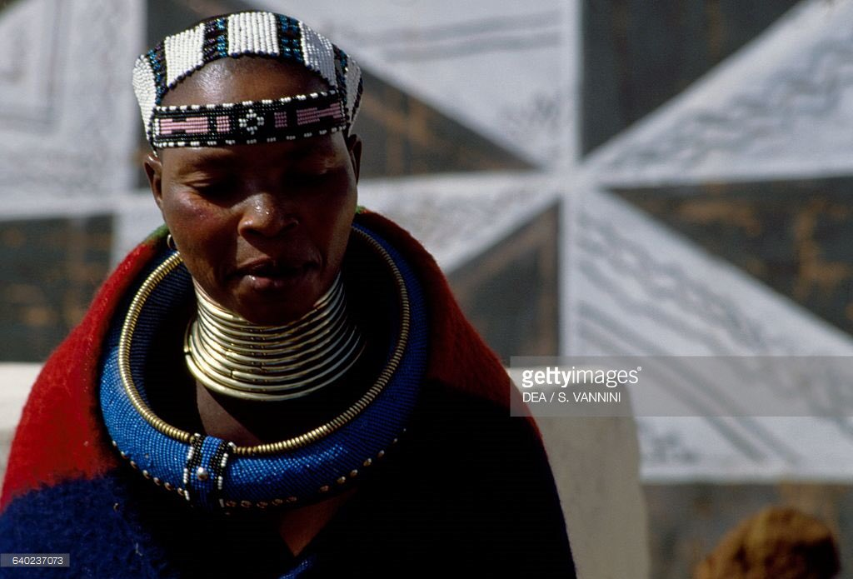  Ndebele neck rings--Ndebele people in Zimbabwe/South Africa wear these rings as a sign of wealth and status
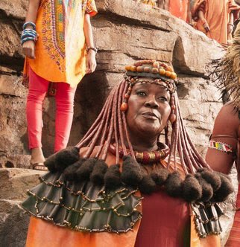 | 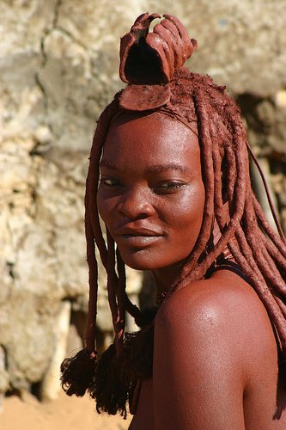  The Himba people of north-western Namibia. The Himba people use red ochre to their skin and hair.
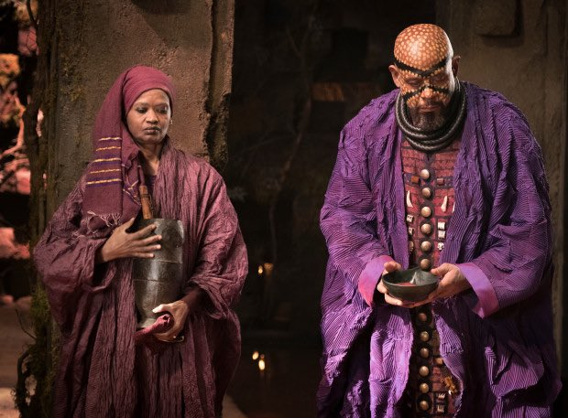 | 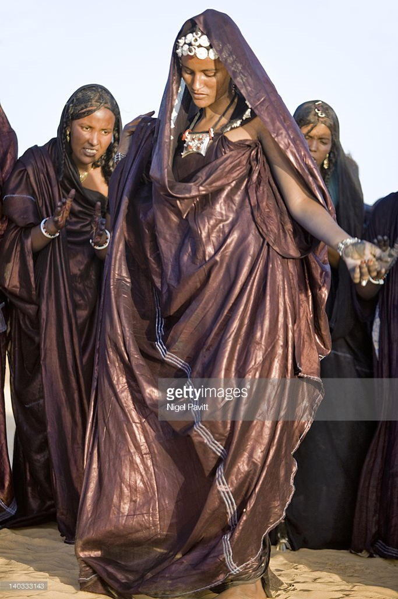  Agbada robes---a robe worn by people in both west Africa and in north Africa
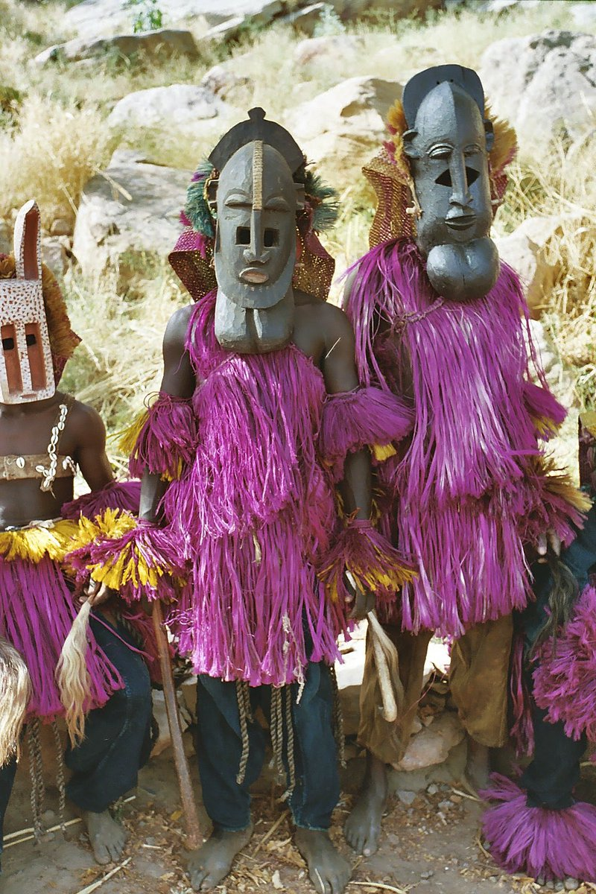 | 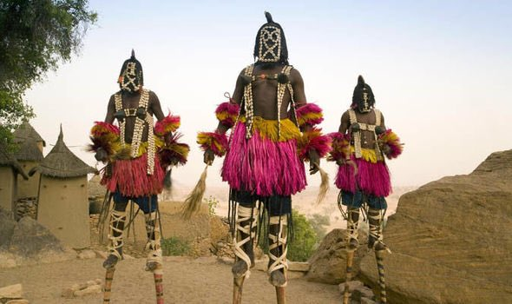  Dogon People---central plateau of Mali
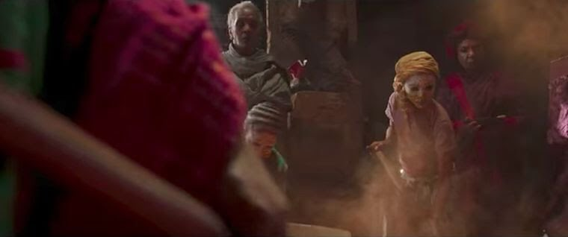 | 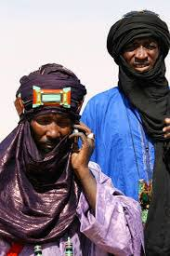Tuareg scarfs-- North and West Africa
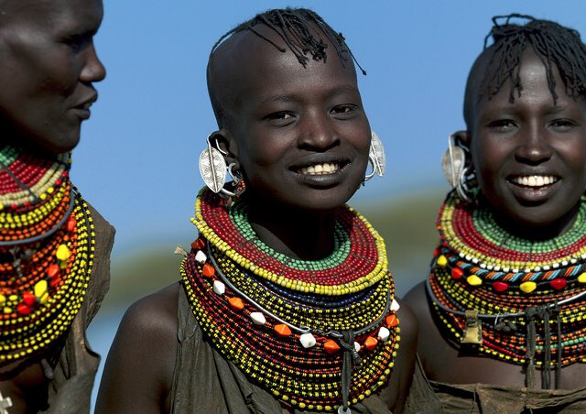
Turkana People----Kenya
The language spoken in Wakonda is Xhosa | A language spoken in South Africa
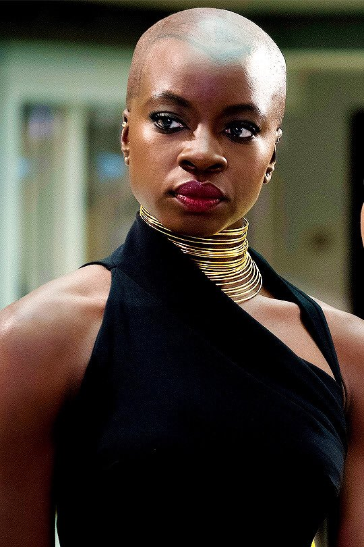 | Actress Danai Gurira is from Zimbabwe
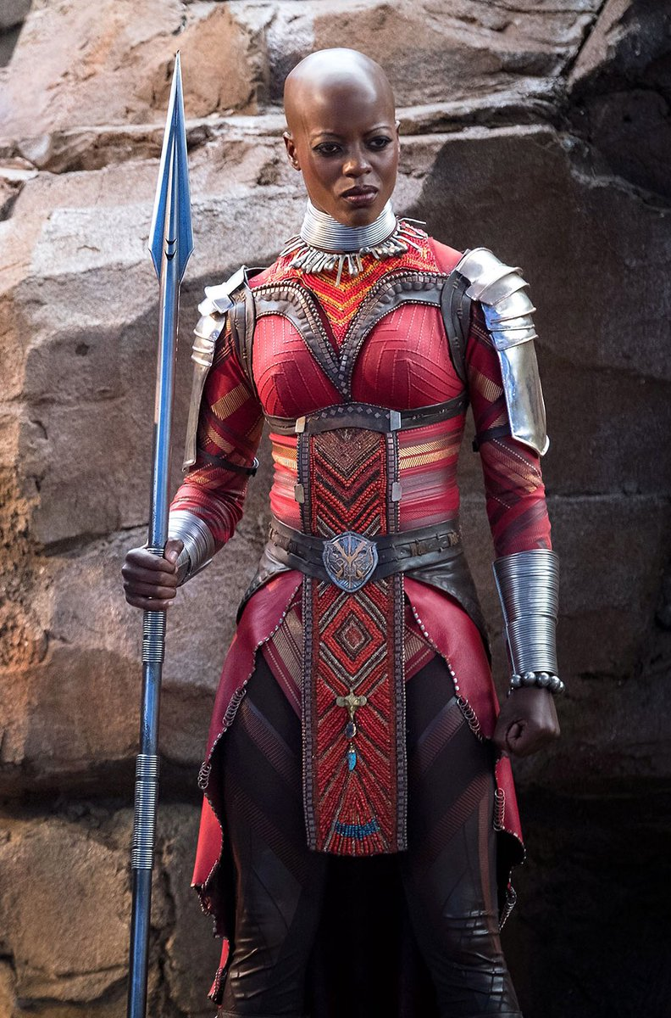 | Actress Florence Kasumba is from Uganda
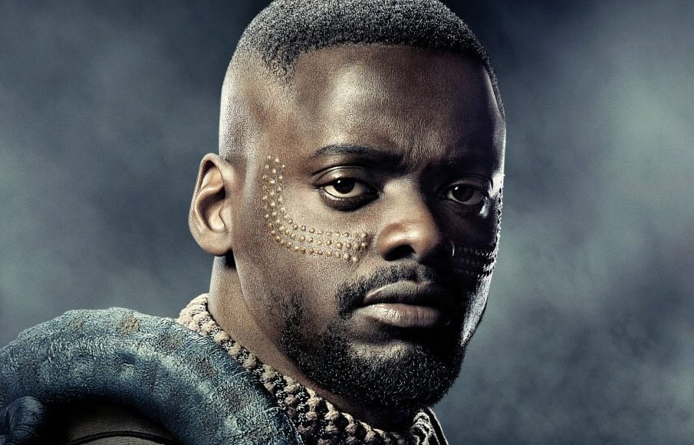 | Actor Daniel Kaluuya is from Uganda
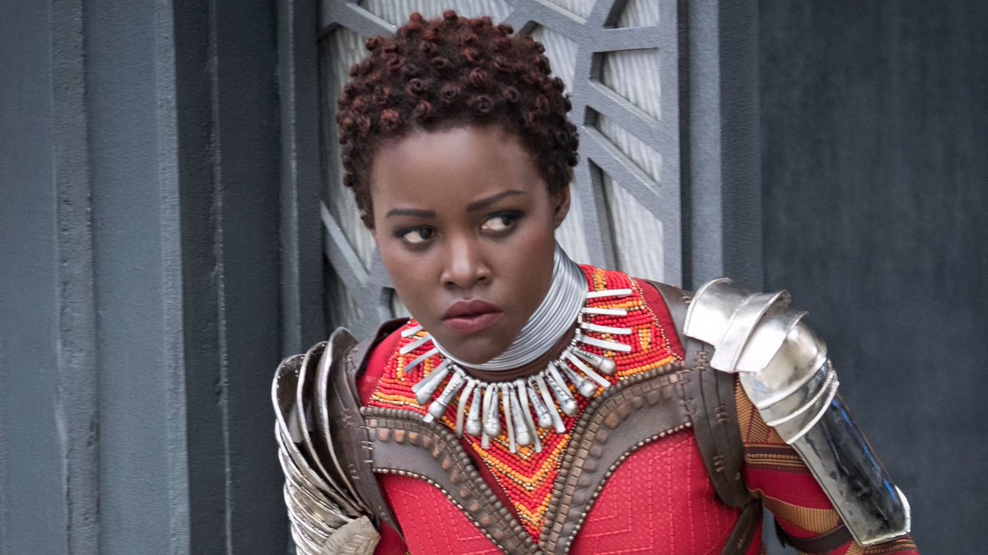 | Actress Lupita Nyongo is from Kenya
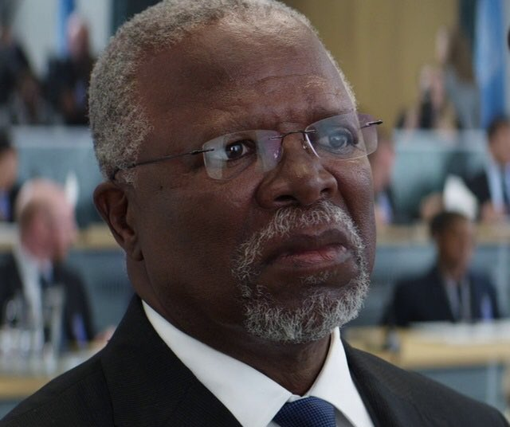 | Actor John Kani is from South Africa
Lupita fights for Boko Haram girls at the start of the film
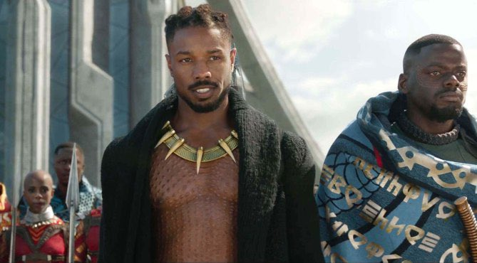 | 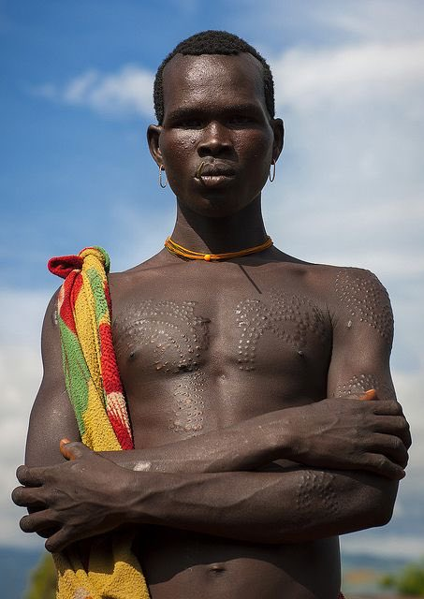  Kilmonger’s tribal markings resemble scar tattoos of the Mursi and Surma in Ethiopia.
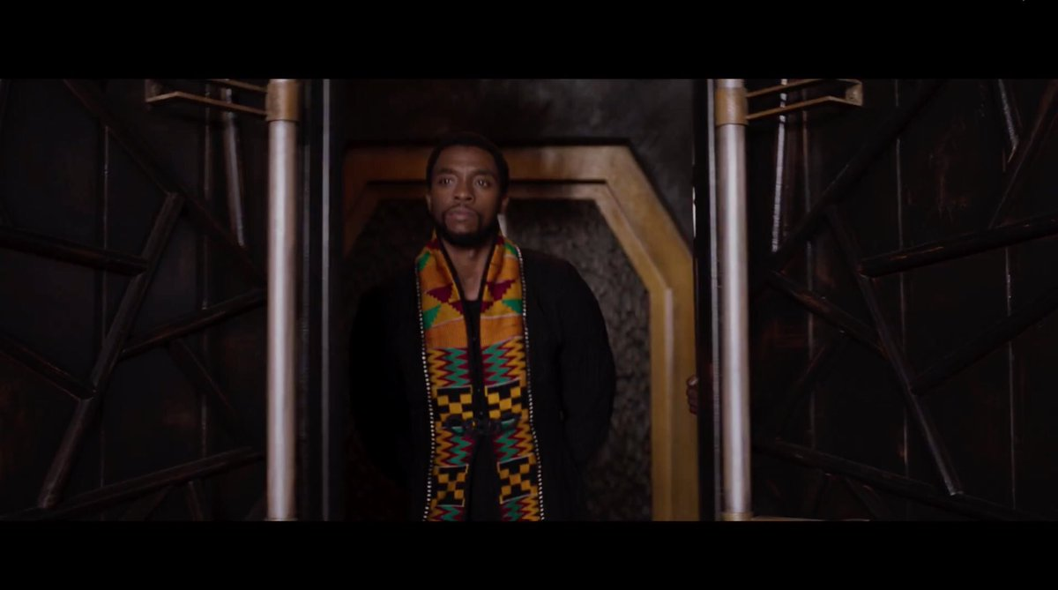 | T’Challa’s kente- Kente is known as nwentom in Akan (the Akan are from Ghana)
 | 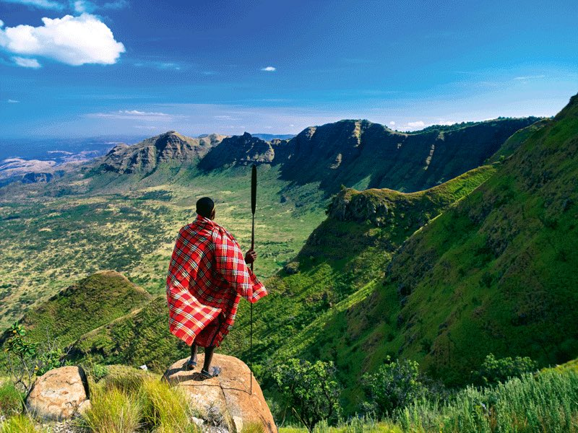  The Great Rift Valley---formed in Kenya 20 million years ago

Post-Viewing:
- T’Challa---A Character Analysis

Name: ________________________ Date: ________________________

T’Challa: T’Challa is the king of Wakanda, and the superhero, the Black Panther. He was a prince of Wakanda, until the death of his father, T’Chaka. His powers come from eating the heart-shaped herb that gives Black Panther power from the panther god Bast.
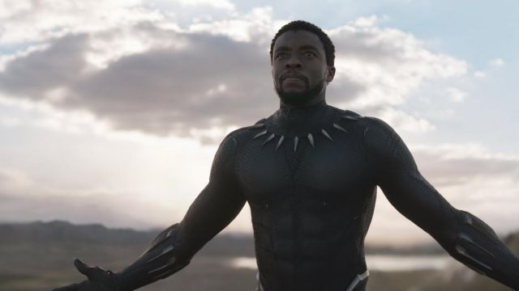

Character Traits: What character traits did T’Challa show?

- ______________________________________
- ______________________________________
- ______________________________________

Special Abilities: What special abilities does T’Challa have?

- ______________________________________
- ______________________________________
- ______________________________________

Actions: What were some of his actions?

- ______________________________________
- ______________________________________
- ______________________________________

What do his actions reveal about his character?

_________________________________________________________________________

_________________________________________________________________________

__________________________________________________________________________

_________________________________________________________________________

Do you agree with all of his actions? Would you do anything differently?

_________________________________________________________________________

_________________________________________________________________________

__________________________________________________________________________

_________________________________________________________________________

II. Killmonger--A Character Analysis

Name: ________________________ Date: ________________________

Erik Killmonger: Killmonger is the “nemesis” of Black Panther. He is a native of Wakanda, but was born in the United States. His father felt as if the people of Wakanda needed to share their hidden resources with Black people struggling throughout the world. Because of this, his father was killed by the Wakandan king, his brother. As a result, Killmonger sought not only vengeance but to use Wakandan resources to also help Black people globally.
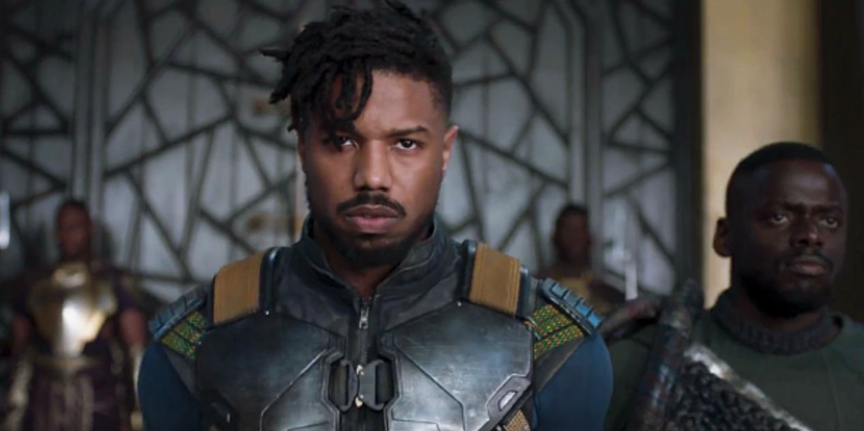

Character Traits: What character traits did Killmonger show?

- ______________________________________
- ______________________________________
- ______________________________________

Special Abilities: What special abilities does he have?

- ______________________________________
- ______________________________________
- ______________________________________

Actions: What were some of his actions?

- ______________________________________
- ______________________________________
- ______________________________________

What do his actions reveal about his character?

_________________________________________________________________________

_________________________________________________________________________

__________________________________________________________________________

_________________________________________________________________________

Do you agree with all of his actions? Would you do anything differently?

_________________________________________________________________________

_________________________________________________________________________

__________________________________________________________________________

_________________________________________________________________________

III. Shuri---A Character Analysis

Name: ________________________ Date: ________________________

Shuri: Shuri is the princess of Wakanda, sister of T’Challa, and is the leader of the Wakandan Design group. She’s innovative and a technological inventor, who is responsible for creating most of Wakanda’s modern technology. She designed the Black Panther’s suit, which gives him many of his abilities. She was responsible for tracking down Klaue, and she helped locate her brother to combat Killmonger.


Character Traits: What character traits did Shuri show?

- ______________________________________
- ______________________________________
- ______________________________________

Special Abilities: What special abilities does she have?

- ______________________________________
- ______________________________________
- ______________________________________

Actions: What were some of her actions?

- ______________________________________
- ______________________________________
- ______________________________________

What do her actions reveal about her character?

_________________________________________________________________________

_________________________________________________________________________

__________________________________________________________________________

_________________________________________________________________________

Do you agree with all of his actions? Would you do anything differently? Do you think she gets enough credit?

_________________________________________________________________________

_________________________________________________________________________

__________________________________________________________________________

_________________________________________________________________________

IV. Black Feminism---the role of Black women in Wakanda

Go Thru PowerPoint:
Exit tickets, writing prompts are in the powerpoint.

https://docs.google.com/presentation/d/1AL41oIhA_PPz-bU5L5Xtz7CS2dRd5i7Phi6edWIcfNQ/edit#slide=id.g33689d8ecf_0_2

V. What does Wakanda Represent----A Debate

I’m sure we all looked at Wakanda in different ways. All of your interpretations are valid, but today I’m asking you to look at two different interpretations as Wakanda. You will then be assigned a position, and we will prepare for a class debate.

Position 1: Wakanda represents Black elitism (specifically in the United States)
Position 2: Wakanda represents a possibility for a Black future

You will be provided with editorials supporting these positions. However, you need to find your own reasoning and evidence from the film as well as background knowledge you have to prepare for this debate.

Debate Preparation Graphic Organizer
Opening Statement (2 minutes)

State your position:

State your three basic points.
1.

2.

3.

Close your opening statement with a significant fact.

State Your Argument in Detail, Citing Passages (2 minutes)

Argument #1: _________________________________________________________
Evidence (from article or film)

Argument #2: _________________________________________________________
Evidence (from article or film)

Argument #3: _________________________________________________________
Evidence (from article or film)

Rebuttal (1 minute)
Opponents Argument:

Counterpoint:

Closing Statement (1 minute)

Summarize your debate points:

VI. Bonus: What Would You Look Like in Wakanda?

Draw a representation of yourself inspired from the film. What would you look like on Wakanda? What would your role be?

____________________________________________________________________________

____________________________________________________________________________

Michigan State University, Exploring Africa Lesson Plans
http://exploringafrica.matrix.msu.edu/the-atlantic-slave-trade-engage/
@diasporicblues, Twitter

